# ELEC5514 Networked Embedded Systems

## Lab Report

|  |  |
| --- | --- |
| Group 22 | |
| Member Name | **SID** |
| Ke Zhang | 450432501 |
| Hao Qin | 440413879 |
| Xiangyu Yan | 450069156 |
| Yahong Liu | 440358628 |

## LAB 1

### I. Introduction

In this lab, the general knowledgeable of ZigBee network and the hardware will be introduced, which is aim to familiar with ZigBee network and the software named Zena. And this lab divided into five parts: Introduce ZigBee, Introduce the hardware, Get familiar with the working environment, Learn how to use ZENA packet sniffer and Run the ZigBee demo.

### II. Lab steps and results

**1 Section 1. Introduction on ZigBee**

In this section, we looked into “ZigBee 2006 Application note (AN1232). By reading this note, we have got general information about ZigBee, such as ZigBee is a wireless protocol implemented in the wireless network with low data rate sensors. And it uses the IEEE 802.15.4 and has network formation, device address assignments, routing, messaging and device discovery functions.

**2 Section 2. Hardware**

For this step, we have learnt about the hardware of ZigBee. In this lab we used demo board (PIC24fj256 MCU) with RF module (MRF24j40) as ZigBee node, Pickit 3 to connect the Demo board with the PC, RS232 cable and Zena network analyzer.

**3 Section 3. Working environment**

In this section, we built the demo applications by following the steps of lab notes and connected devices with PC.

**4 Section 4. Zena network sniffer**

We did every single steps of section 4 that is shown in QuickStartGuide and changed the channel to our group number 22. The result is shown below:

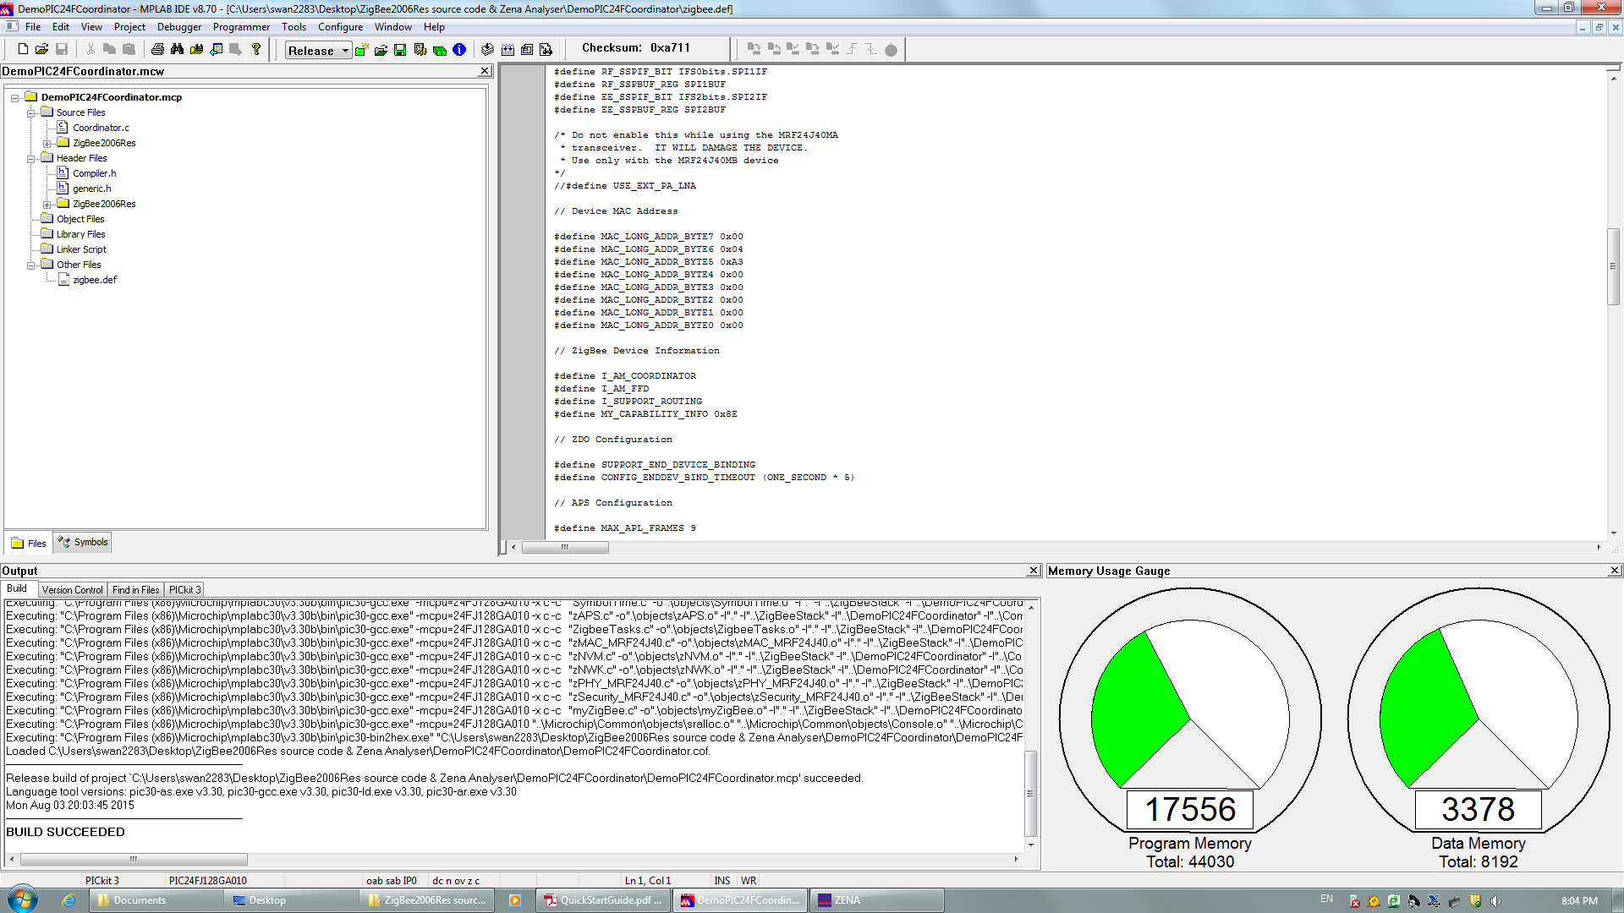 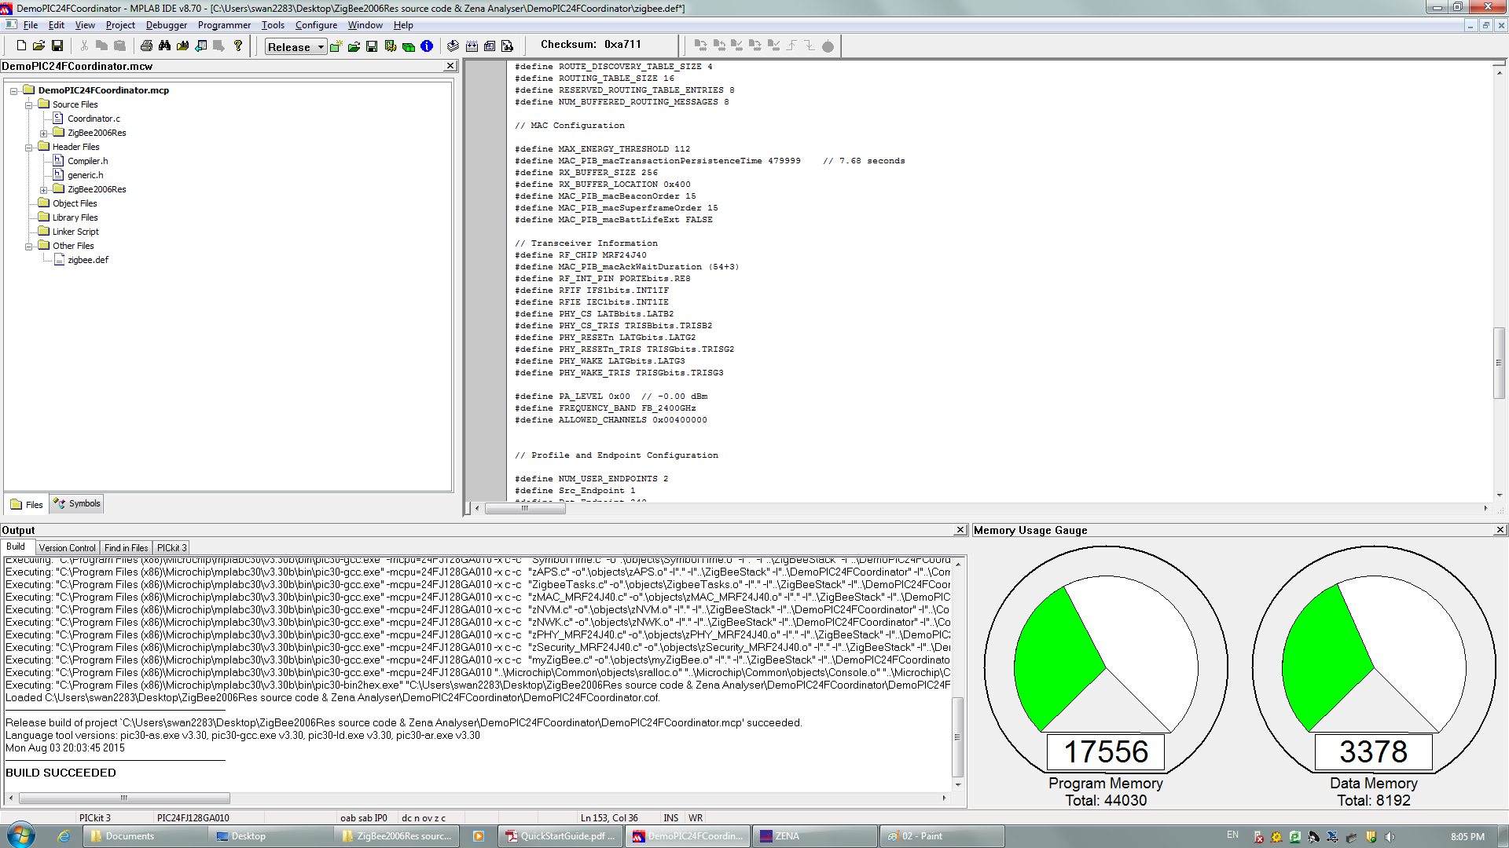

Figure 1.1

And the network topology is:

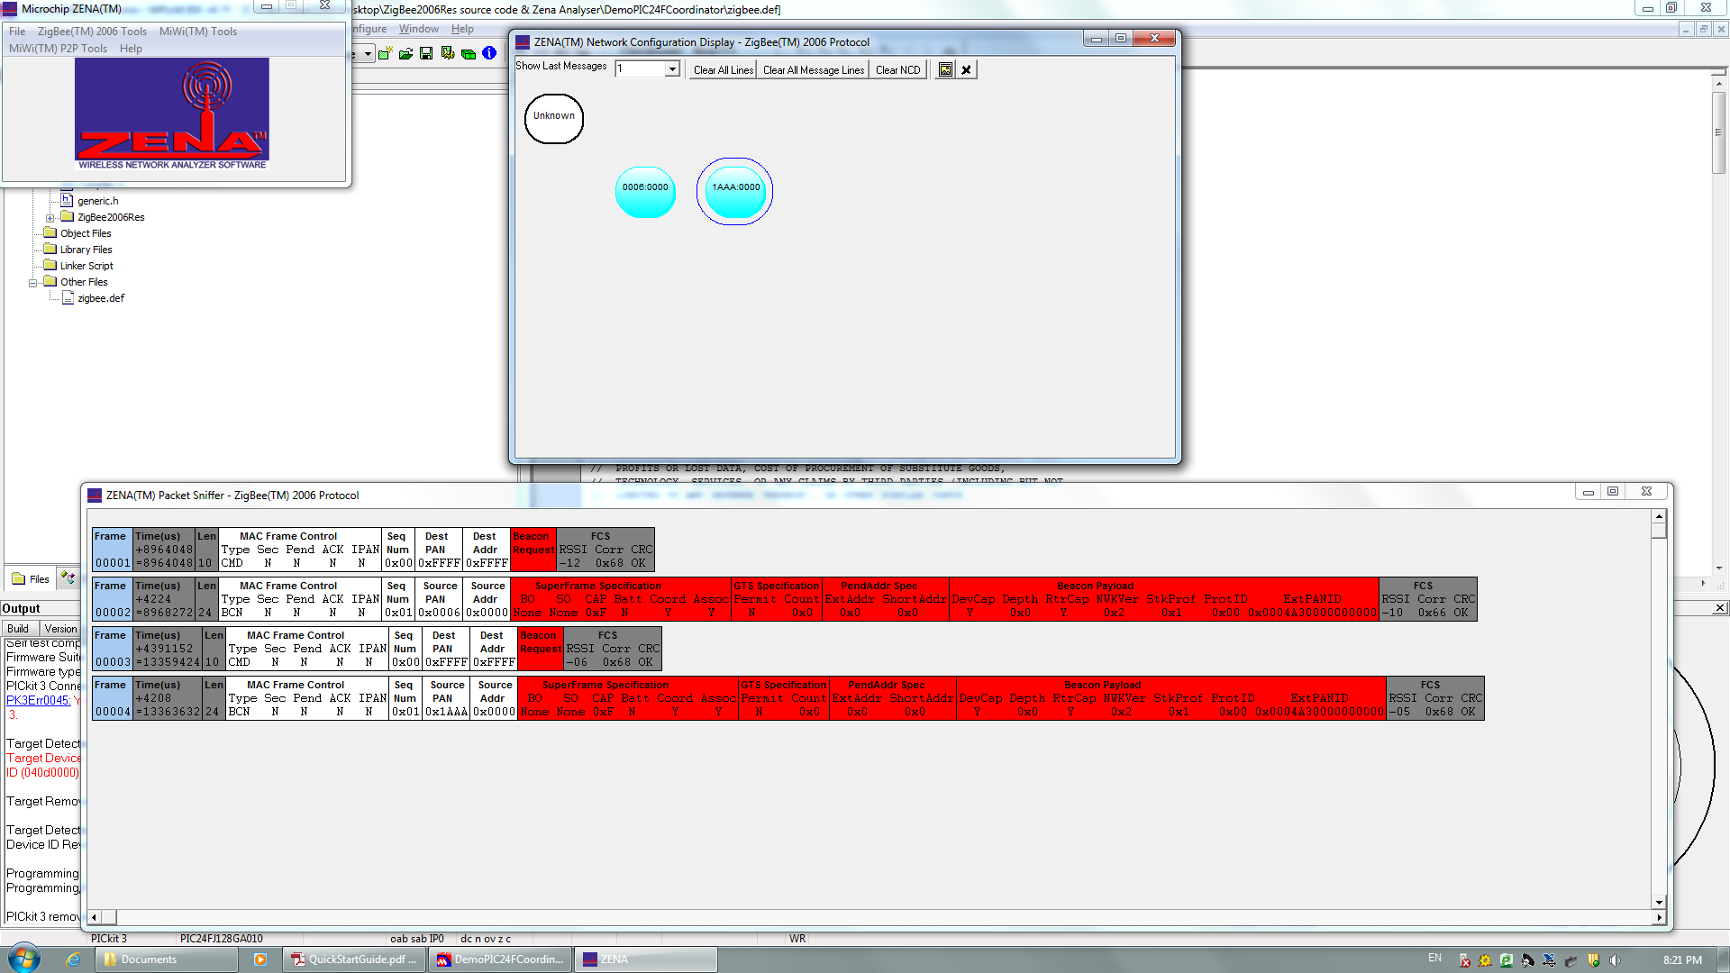

Figure 1.2

**5 Section 5. Run the ZigBee demo**

Firstly, we programed two devices, coordinator and one router.

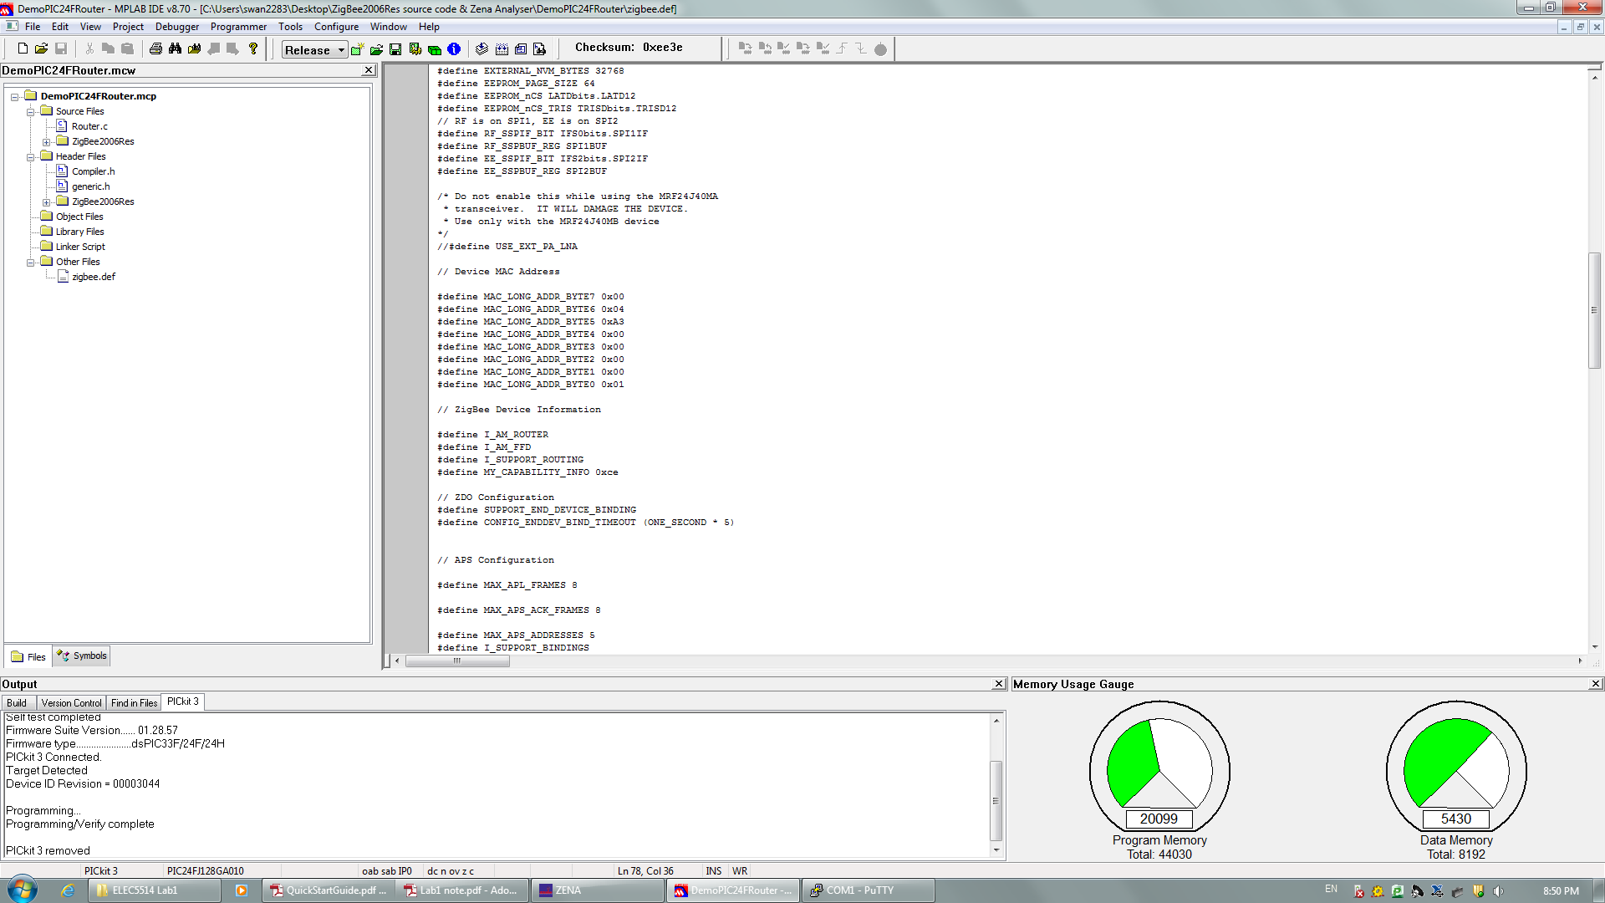

Figure 1.3

Then switch the device power off. And connected a RS-232 cable from the coordinator device to the PC. Finally, opened up a Putty window on the PC to the COM port. Hit the ‘Enter’, the menu system showed as below:

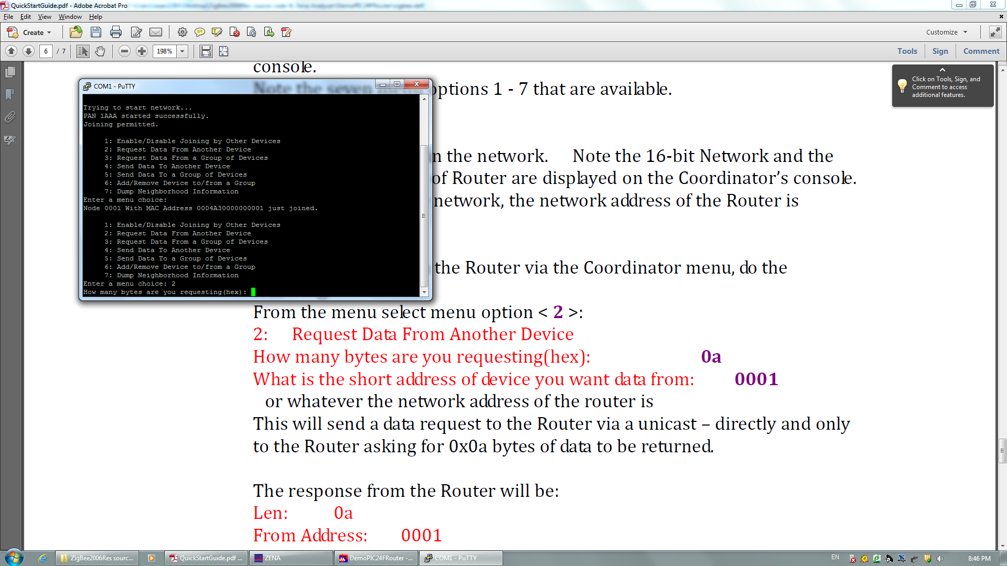

Figure 1.4

Then we typed 2 in the menu, the figure below shows the result:

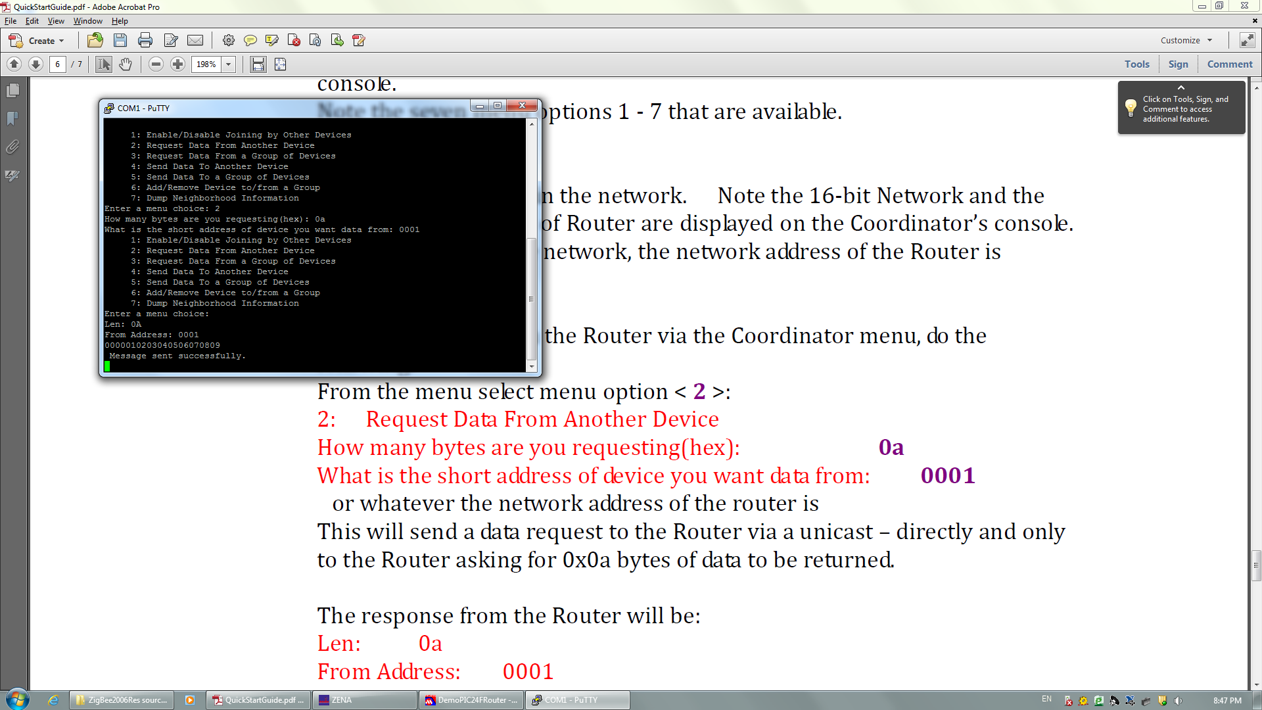

Figure 1.5

Then select option 4, the result is:

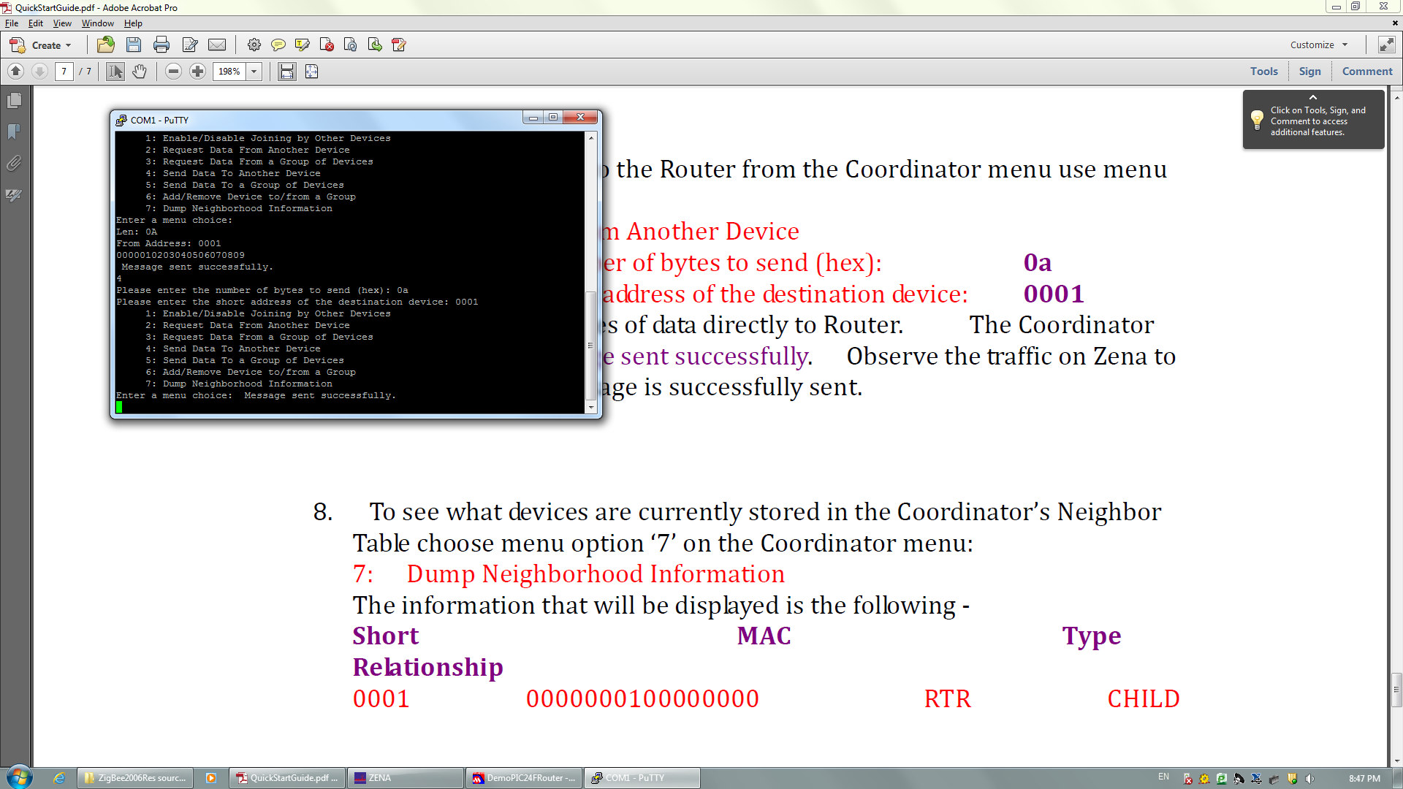

Figure 1.6

The result of option 7 is shows as below:

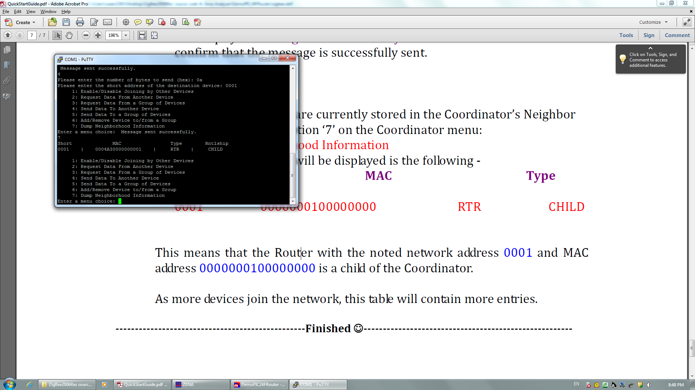

Figure 1.7

### III. Conclusion

In this lab, we have learnt the general knowledgeable of ZigBee network and the hardware of this system, and got familiar with the working environment, learnt how to use ZENA packet sniffer. Also, the demo code was understood.

## LAB 2

### I. Introduction

This report includes two sections:

1. ZigBee network layer basics.
2. Try ZigBee networking through PuTTy.

### II. Lab steps and results

**1 Section 1**

The ZigBee coordinator use NWK (Network layer) to start new network, it can also provide new addressing to the device that joined the network.

There are three topologies for the ZigBee NWK: star, tree and mesh. For the star topology, the coordinator controls other end devices directly. In Figure2.1 the blue one represents the coordinator, in the PuTTy window we select option 1 and then choose enable join to let other devices join the coordinator, the pink one is an end device who join the network.

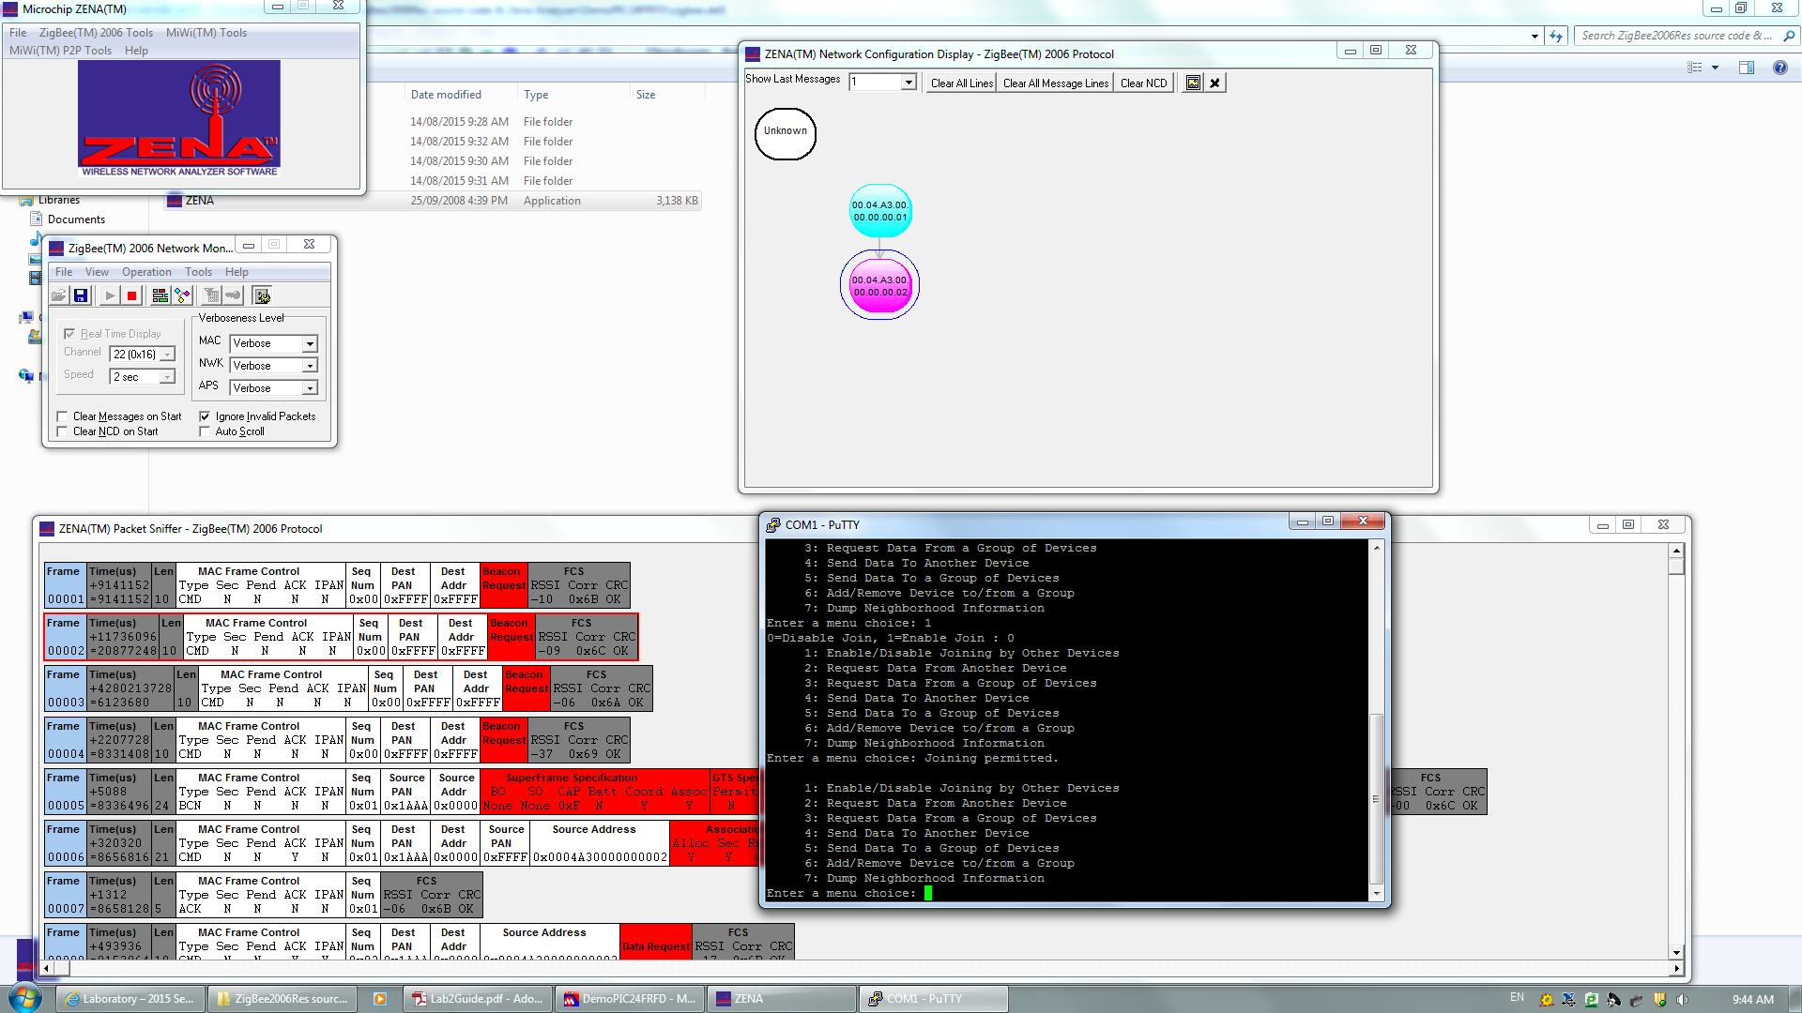

Figure 2.1

After that, we disable the join option of the coordinator, then setup a new device.



Figure 2.2

As shown in Figure2.3, the yellow one is the new device, it connects with the device we use in the last step. Otherwise, it will connect the coordinator if we do not disable the join for the coordinator, which shown in Figure2.4

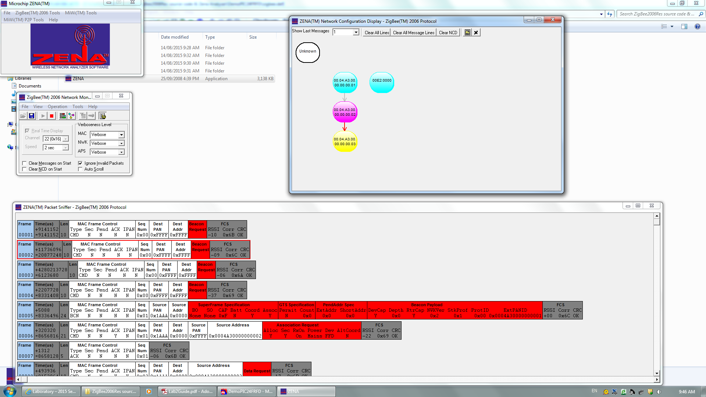

Figure 2.3

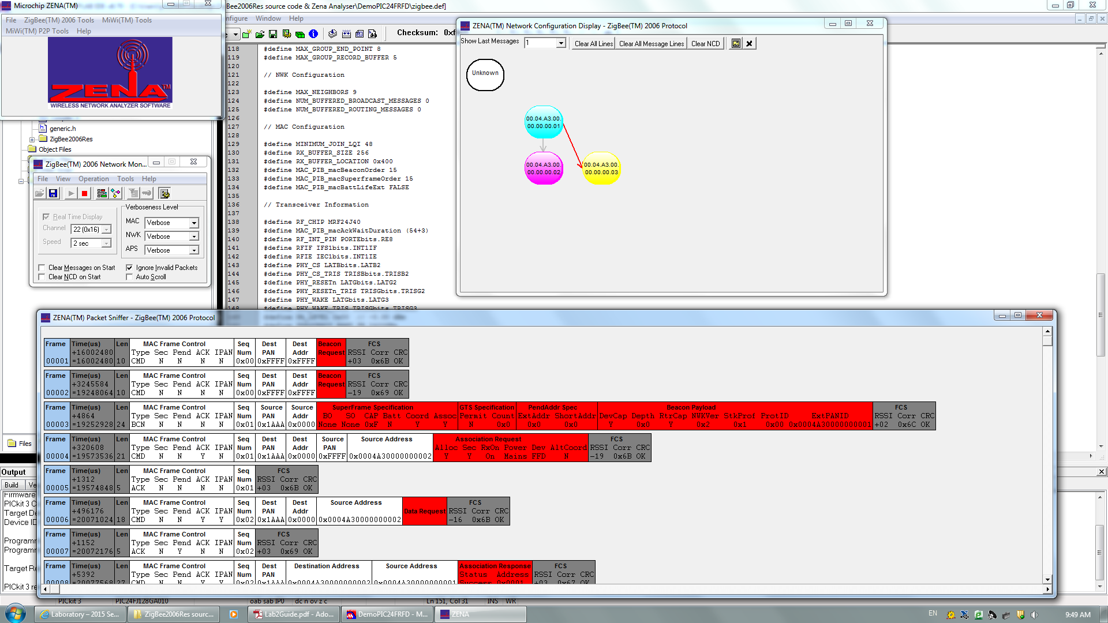

Figure 2.4

Here the figure2.3 refers to tree topology and the Figure2.4 refers to star topology.

**2 Section 2**

In this section, we establish a real ZigBee connection which include sending and receiving messages

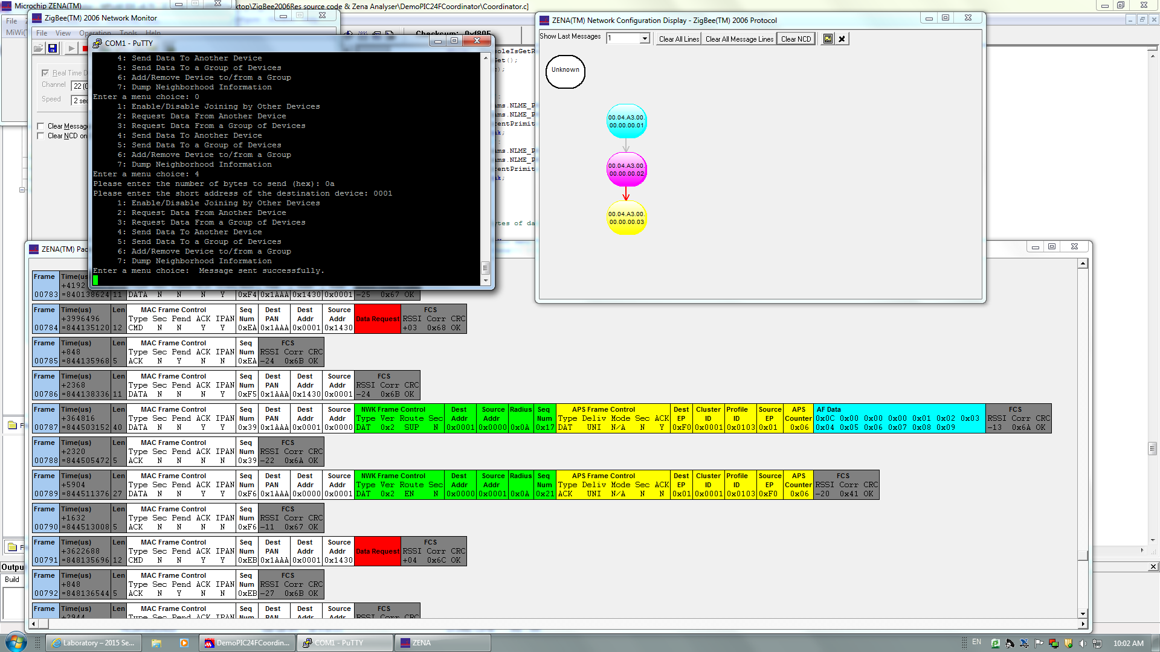

Figure 2.5

As shown in Figure2.5, we can see MAC header (white part) and Network header (green part), in these two parts, we can easily find the Dest address and Source address.

There are three routing modes: suppress, enable and force. In this section, we only focus on the enable and suppress modes. Firstly, we program the enable modes, as shown in figure2.6 we write the codes from lab guide to change it.

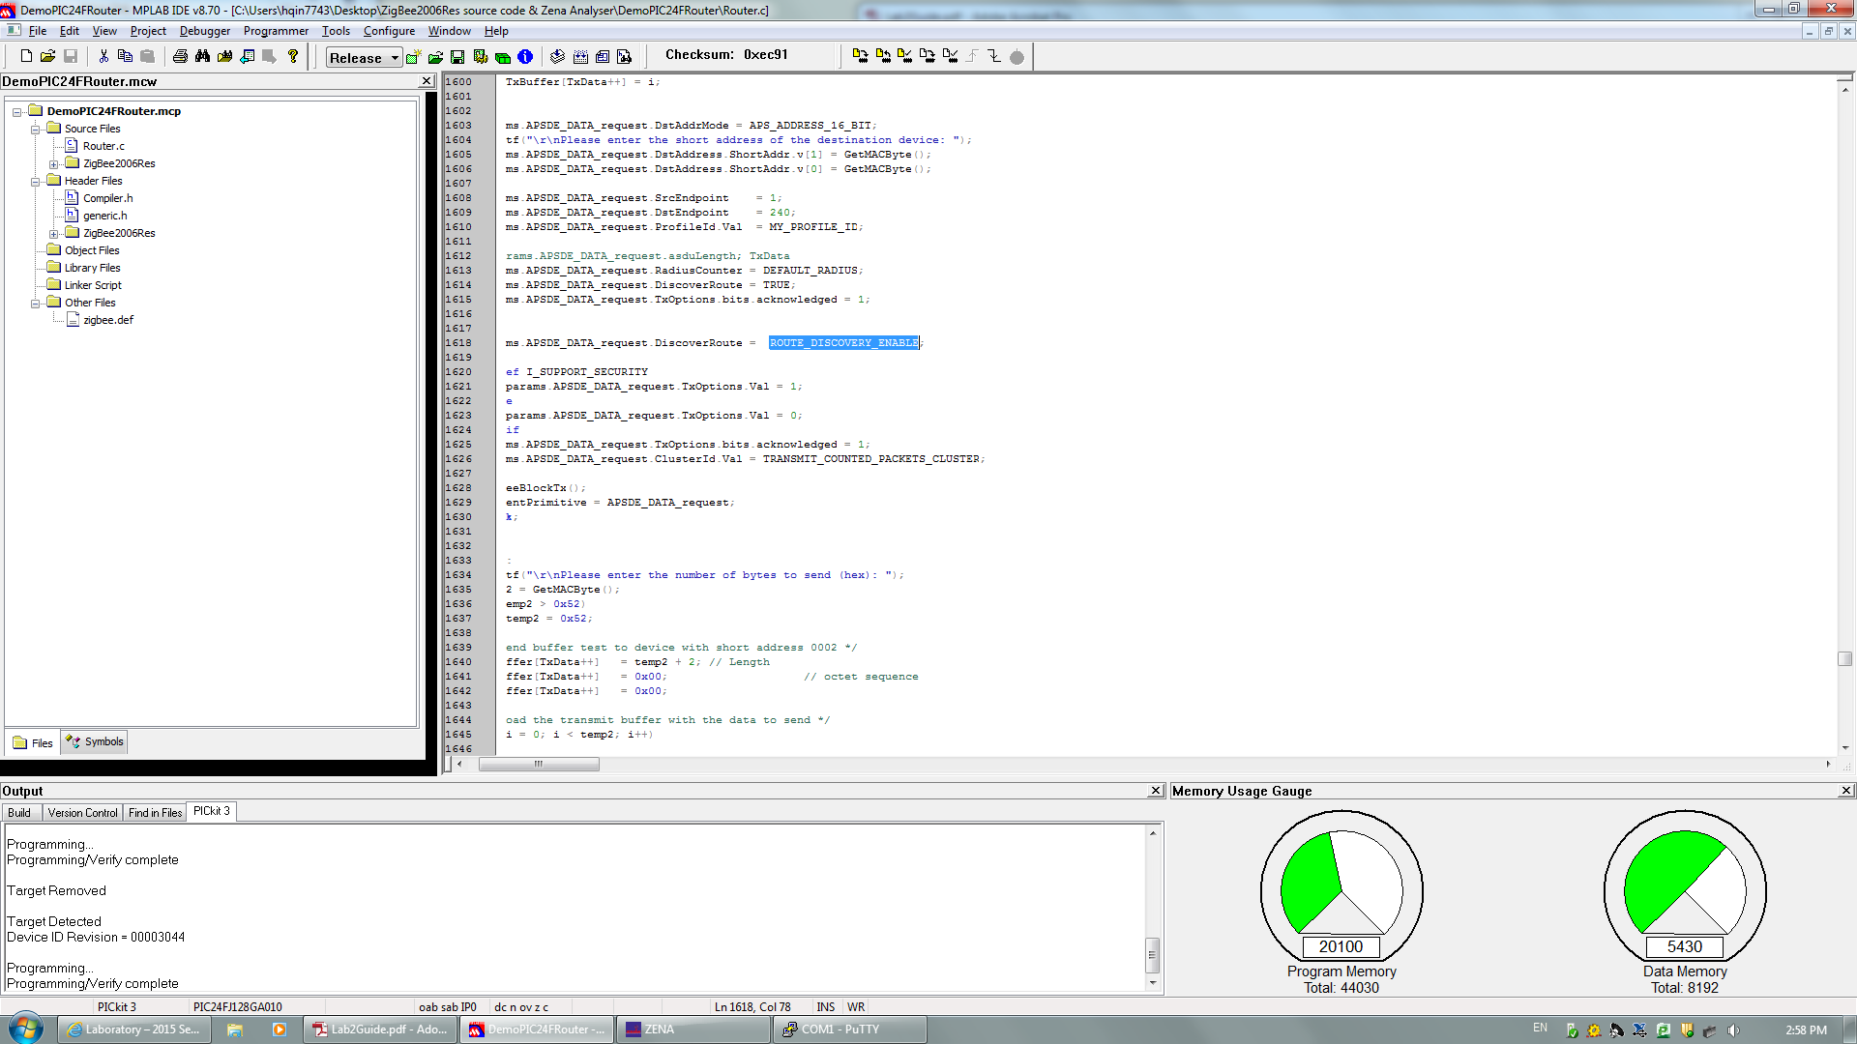

Figure 2.6

And now we can get the enable modes, we can check the result in Zena windows, in the Network header, we can see the EN which means the enable modes.

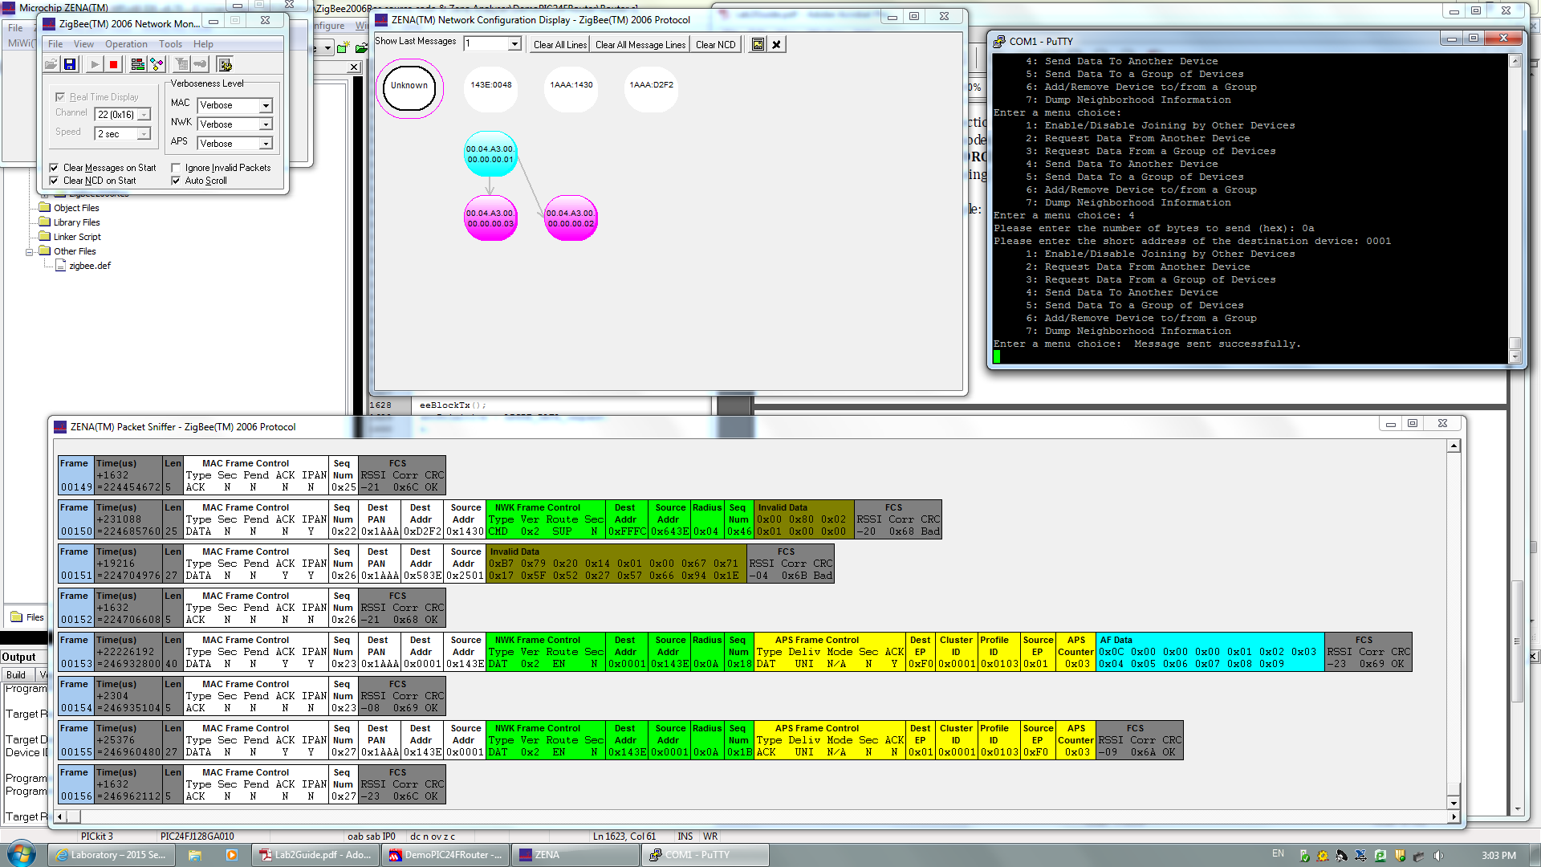

Figure 2.7

Next, we program the suppress modes by using the same way, as shown in figure2.8.

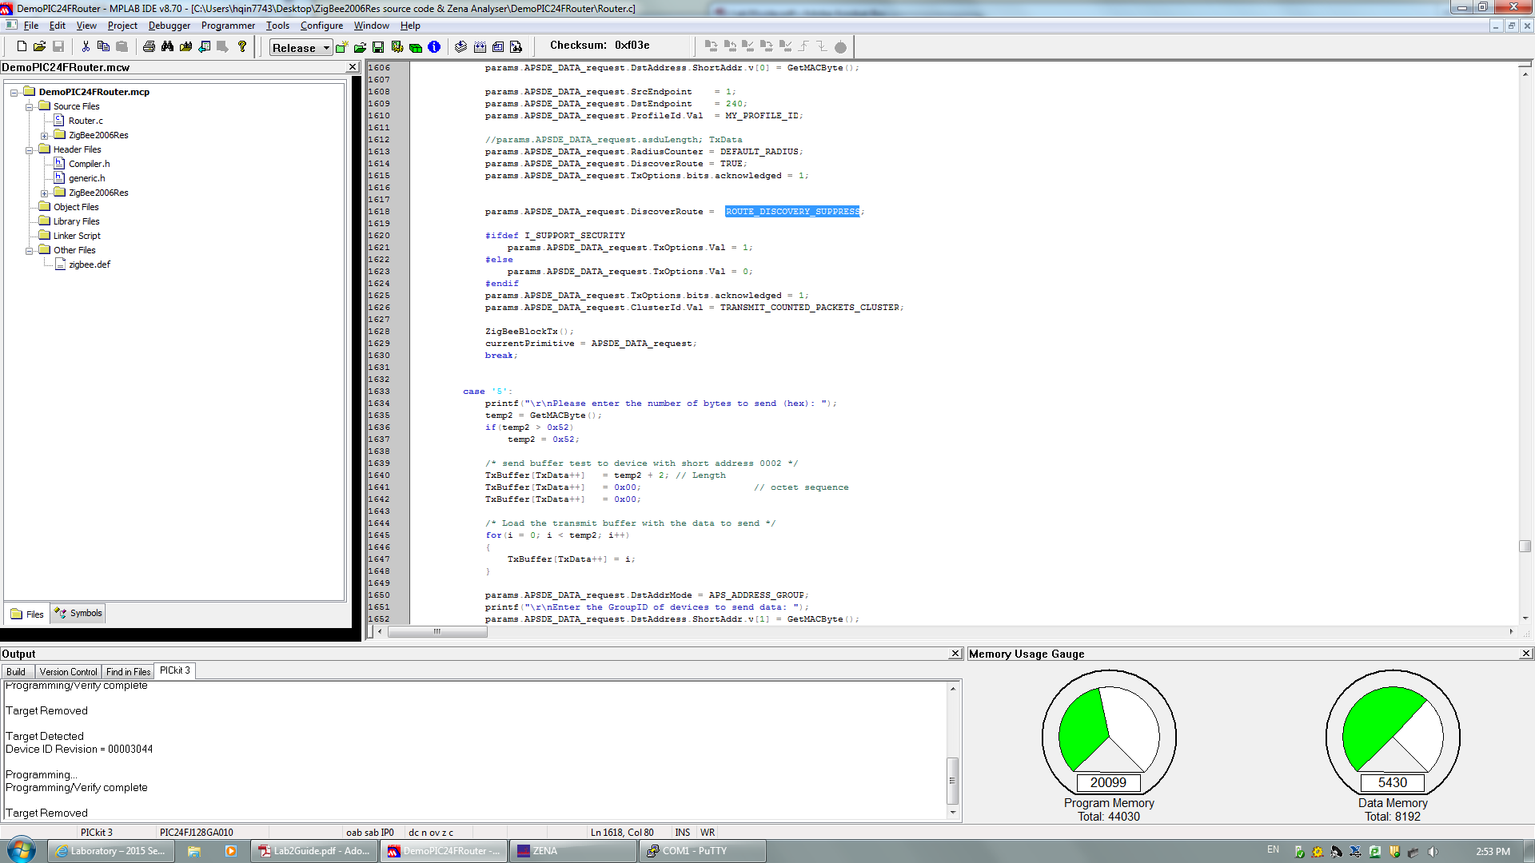

Figure 2.8

And now we can get a suppress modes, just check the Zena result shown in figure2.9.

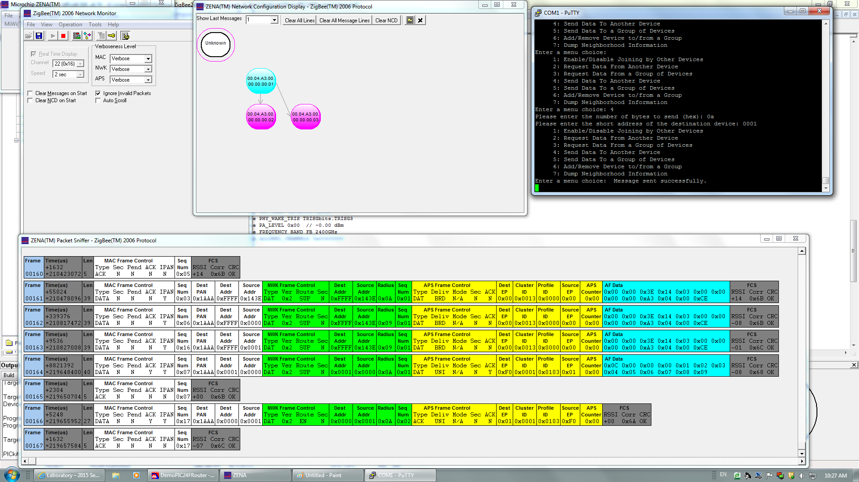

Figure 2.9

And now we get the suppress mode and we can see the packet capturing clearly.

### III. Conclusion

In this lab, we learned how to construct a ZigBee network and the basic wireless sensor network constructing methods. In addition, we got familiar with the operation with the devices.

## Lab 3

### I. Introduction

In this lab, we will start to learn the ZigBee source code structure, and how to program the ZigBee node by C language.

### II. Lab steps and results

**1 Section 1**

In this section, we investigate the source code of the ZigBee stack, we need to read the “Coordinator.c” file and try to understand the structure in the code.

**2 Section 2**

For this section, we first read the menu of the “Coordinator.c” file to understand the how its written and how the functions work.

Figure3.1 is the picture of menu selections.

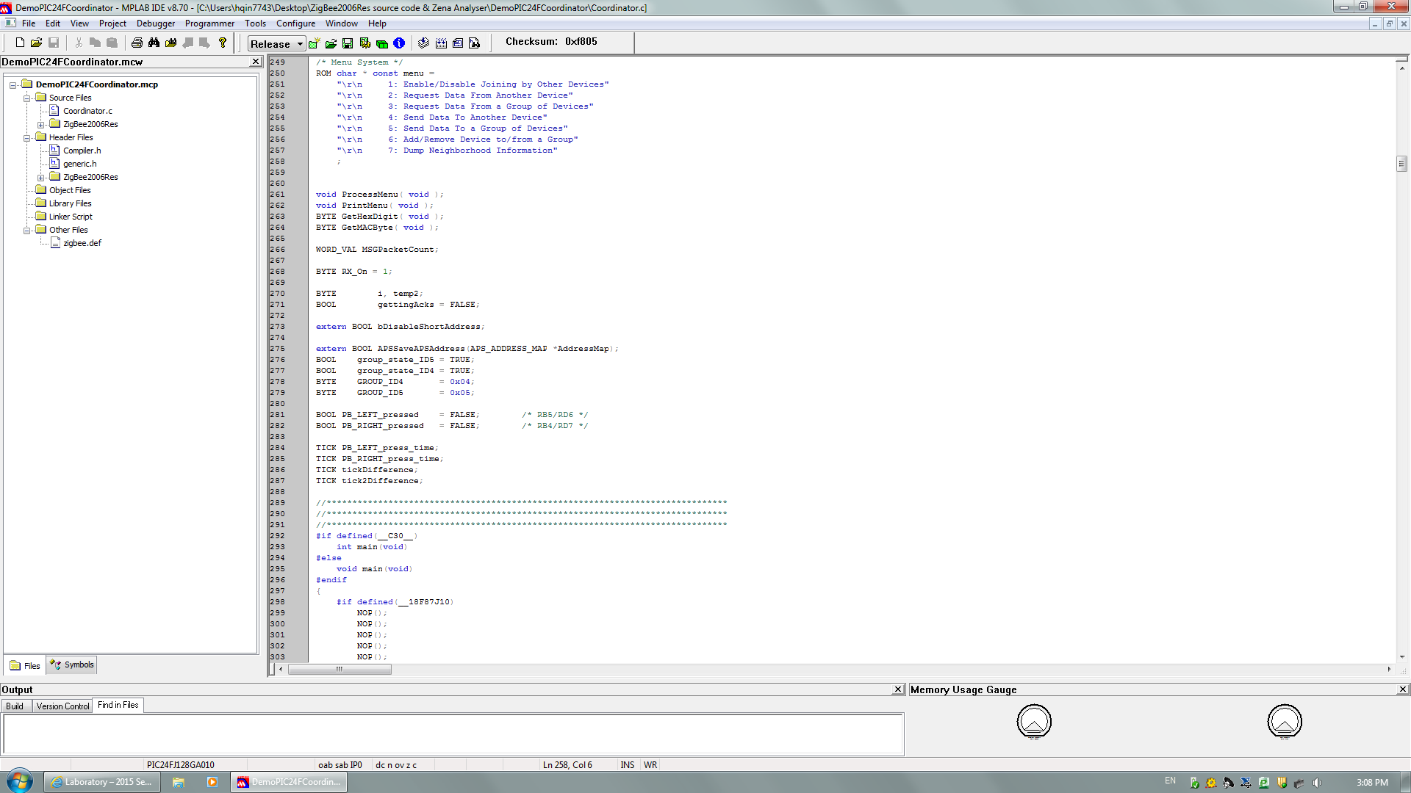

Figure 3.1

Figure3.2 shows the cases for each menu selection.

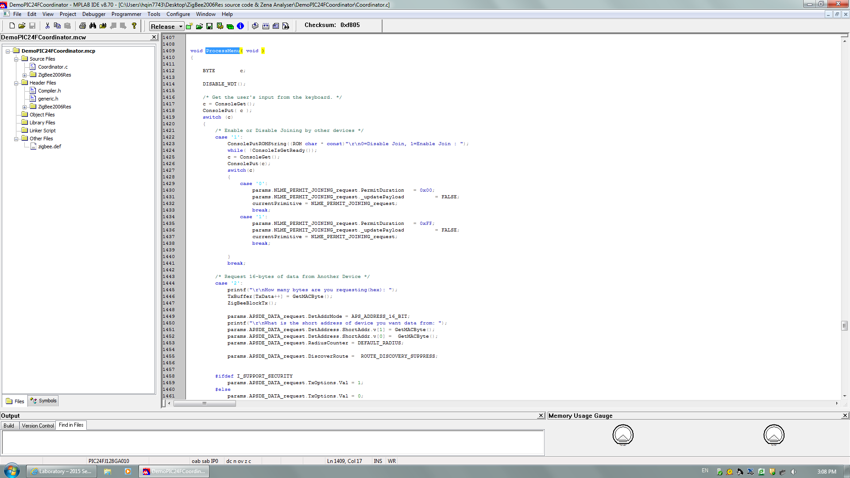

Figure 3.2

Then we try to modify the menu, we add an extra choice on the menu to display a string of characters. As shown, we add case 8 option.

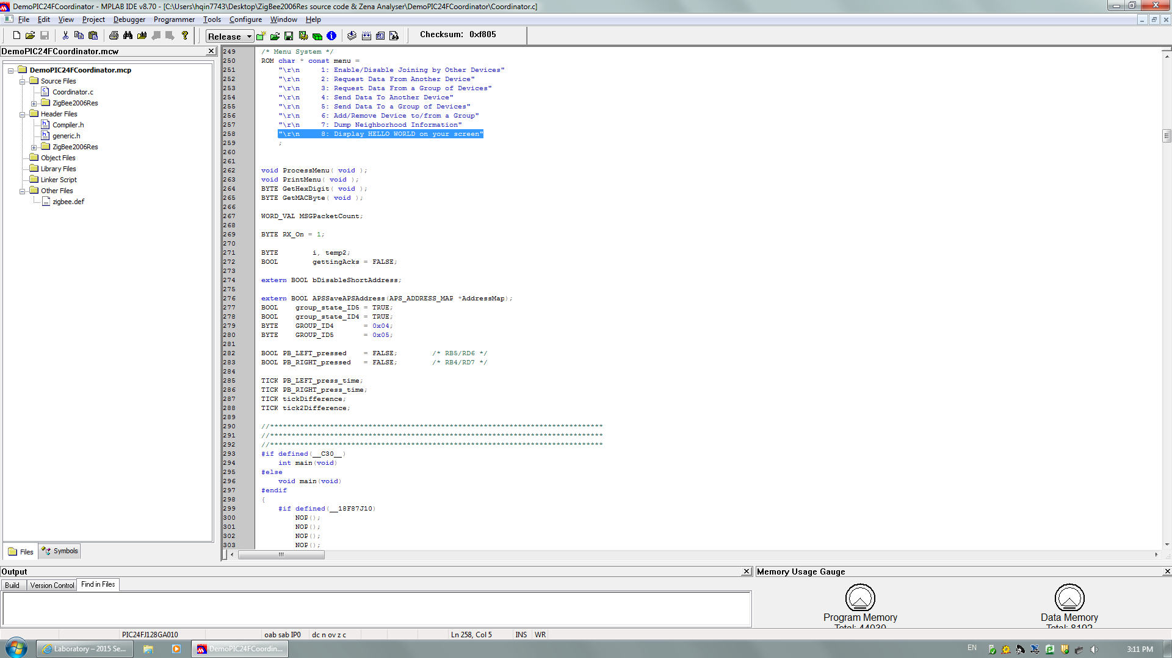

Figure 3.3

This is our detailed C code for case 8 in order to display a string of characters.

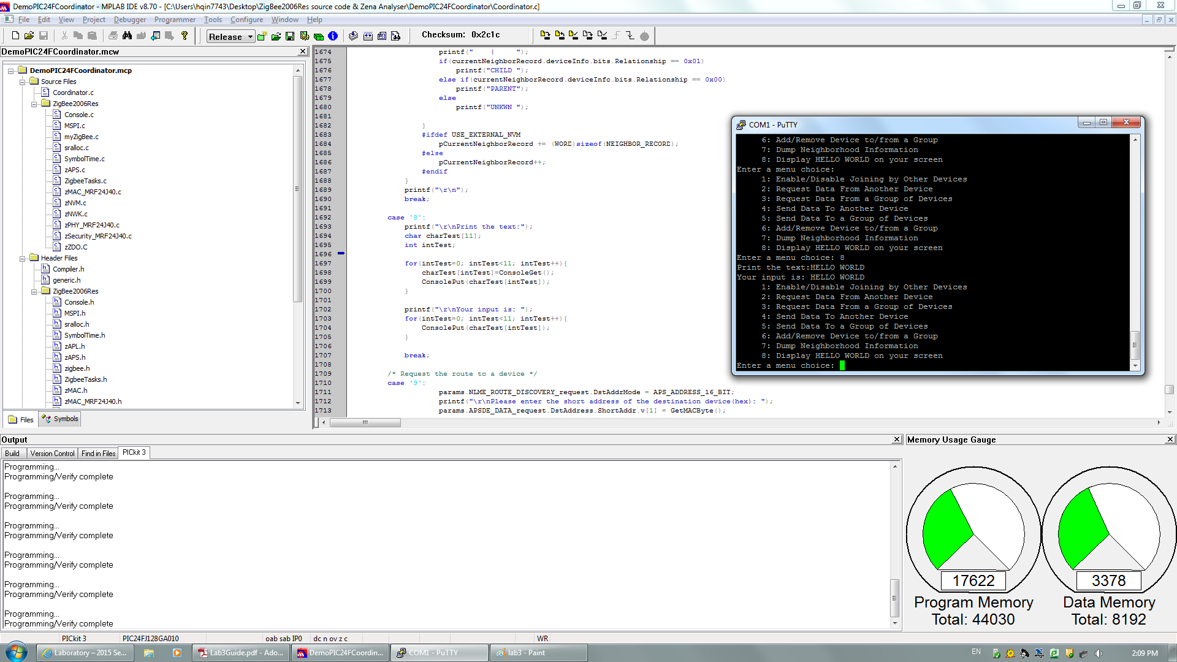

Figure 3.4

Figure3.5 shows the console output.



Figure 3.5

### III. Conclusion

In this lab, we learned some information and knowledge about the structure of the source code and did some modification on the functions.

## LAB 4

### I. Introduction

In this lab, we have two program tasks, first is to calculate and display the sum of 2 numbers and second is convert decimal number to a hex number.

### II. Lab steps and results

**1 Section 1:**

In this part we need to calculate and display the sum of two decimal input numbers which from 0 to 9, and turn it into hex value.

The code is displayed as follow.

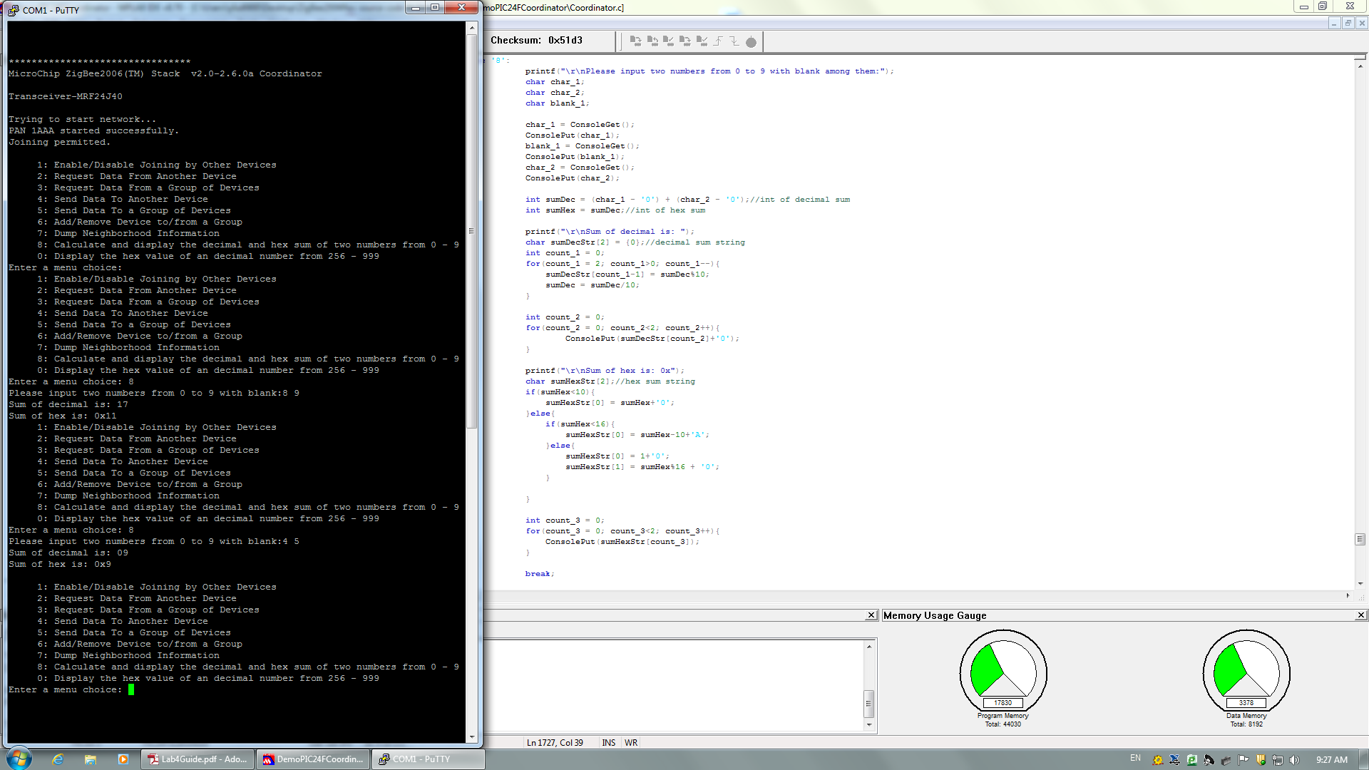

Figure 4.1

And the outcome is shown in the putty interface, when we input 4 and 5 the sum is displayed as 9 along with its hex value 0x9.



Figure 4.2

**2 Section 2:**

In this section we will try to input a decimal value with wider range (from 256 to 999) and then convert it into hex form and output it.

The code we programmed is shown as follow.

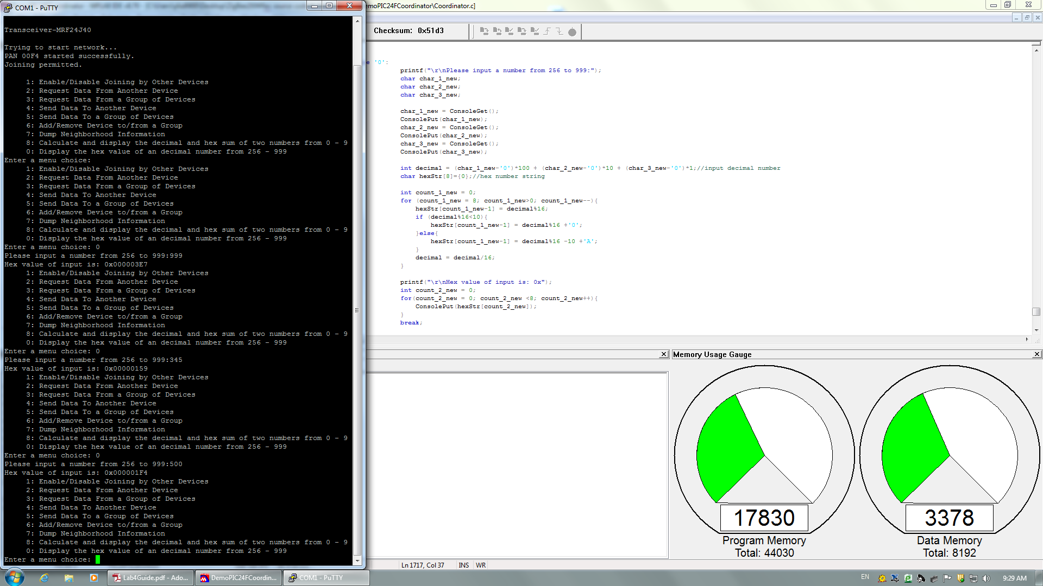

Figure 4.3

As shown in the putty interface, when we input decimal value 999, 345 and 500, we get 0x000003E7, 0x00000159 and 0x000001F4 respectively.



Figure 4.4

### III. Conclusion

In this lab, we reviewed the C language and used that to add some new function for the source code.

## LAB 5

### I. Introduction

We learned about the ZigBee endpoints and clusters structures in this lab. We learned about the actual condition when transmitting packets through ZigBee networks. This lab allows us to set up the endpoints and clusters in a ZigBee network.

### II. Lab steps and results

**1 Section 1:**

We learned about the structure of the ZigBee network application layer. Generally, the ZigBee network consists of three-level addresses. The above is the network address and next level is the endpoint address, following by the cluster address.

We need to specify these two addresses before setting up the ZigBee networks.

**2 Section 2:**

In this part, we tried to realize the two tasks of lab4 based on the endpoints and clusters.

The endpoint and cluster are set as below:

Coordinate Endpoint ID: 171

Coordinate Cluster ID: 0x0002

Router Endpoint ID: 172

Router Cluster ID: 0x1111

**2.1 Task 1:**

The program is as below:

Coordinator transmits two numbers to router:

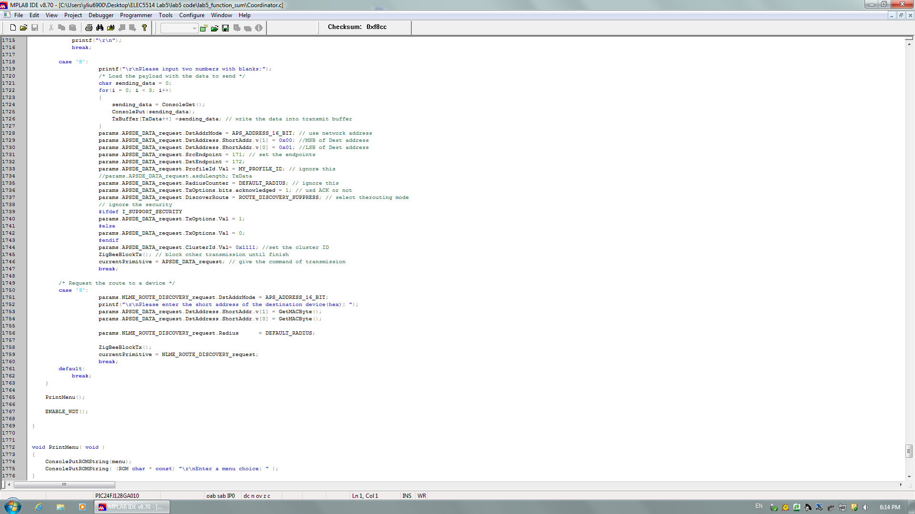

Figure 5.1

Router receives the packet and calculate the summary of two numbers, then transmit it back to coordinator:

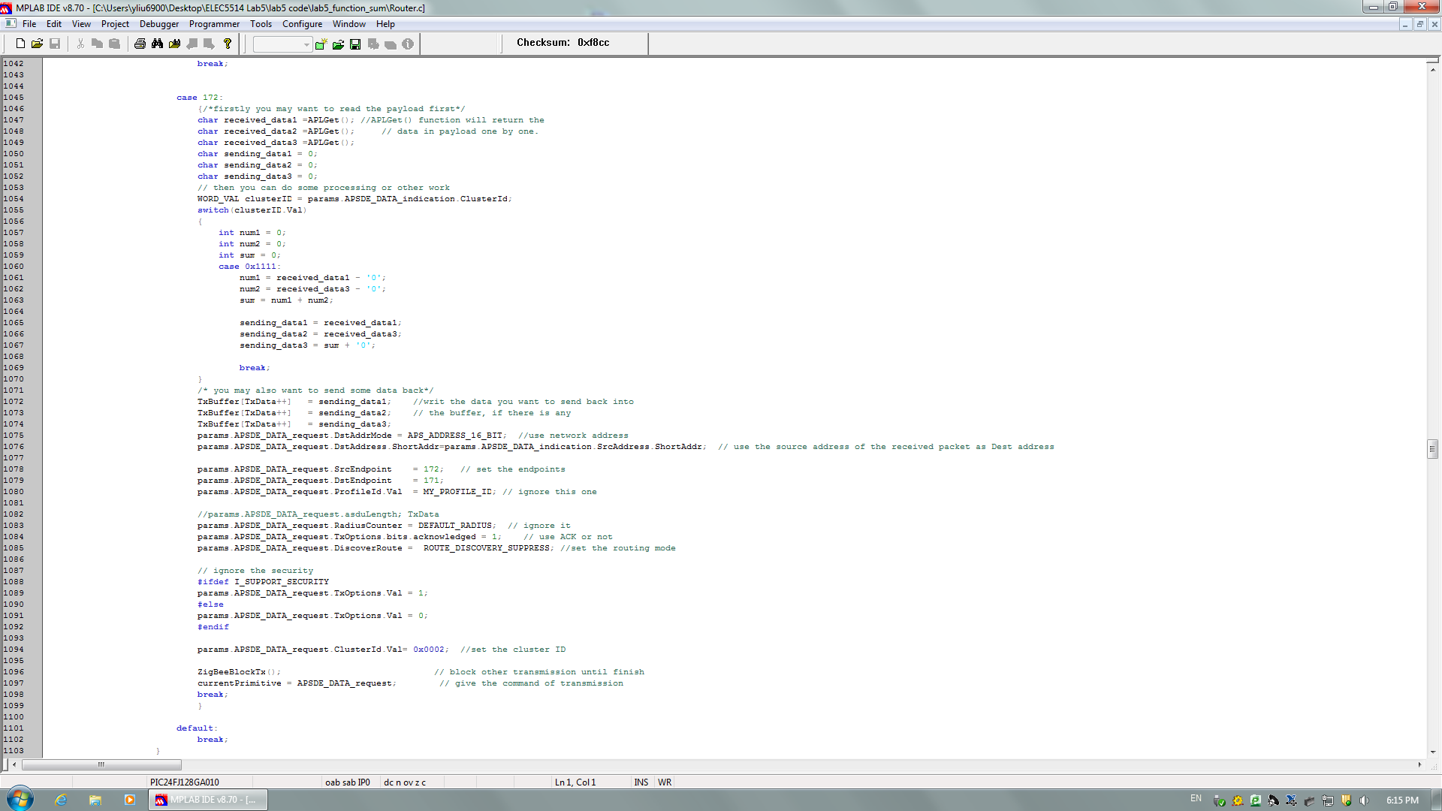

Figure 5.2

Coordinate receives the sum and display it on the console:

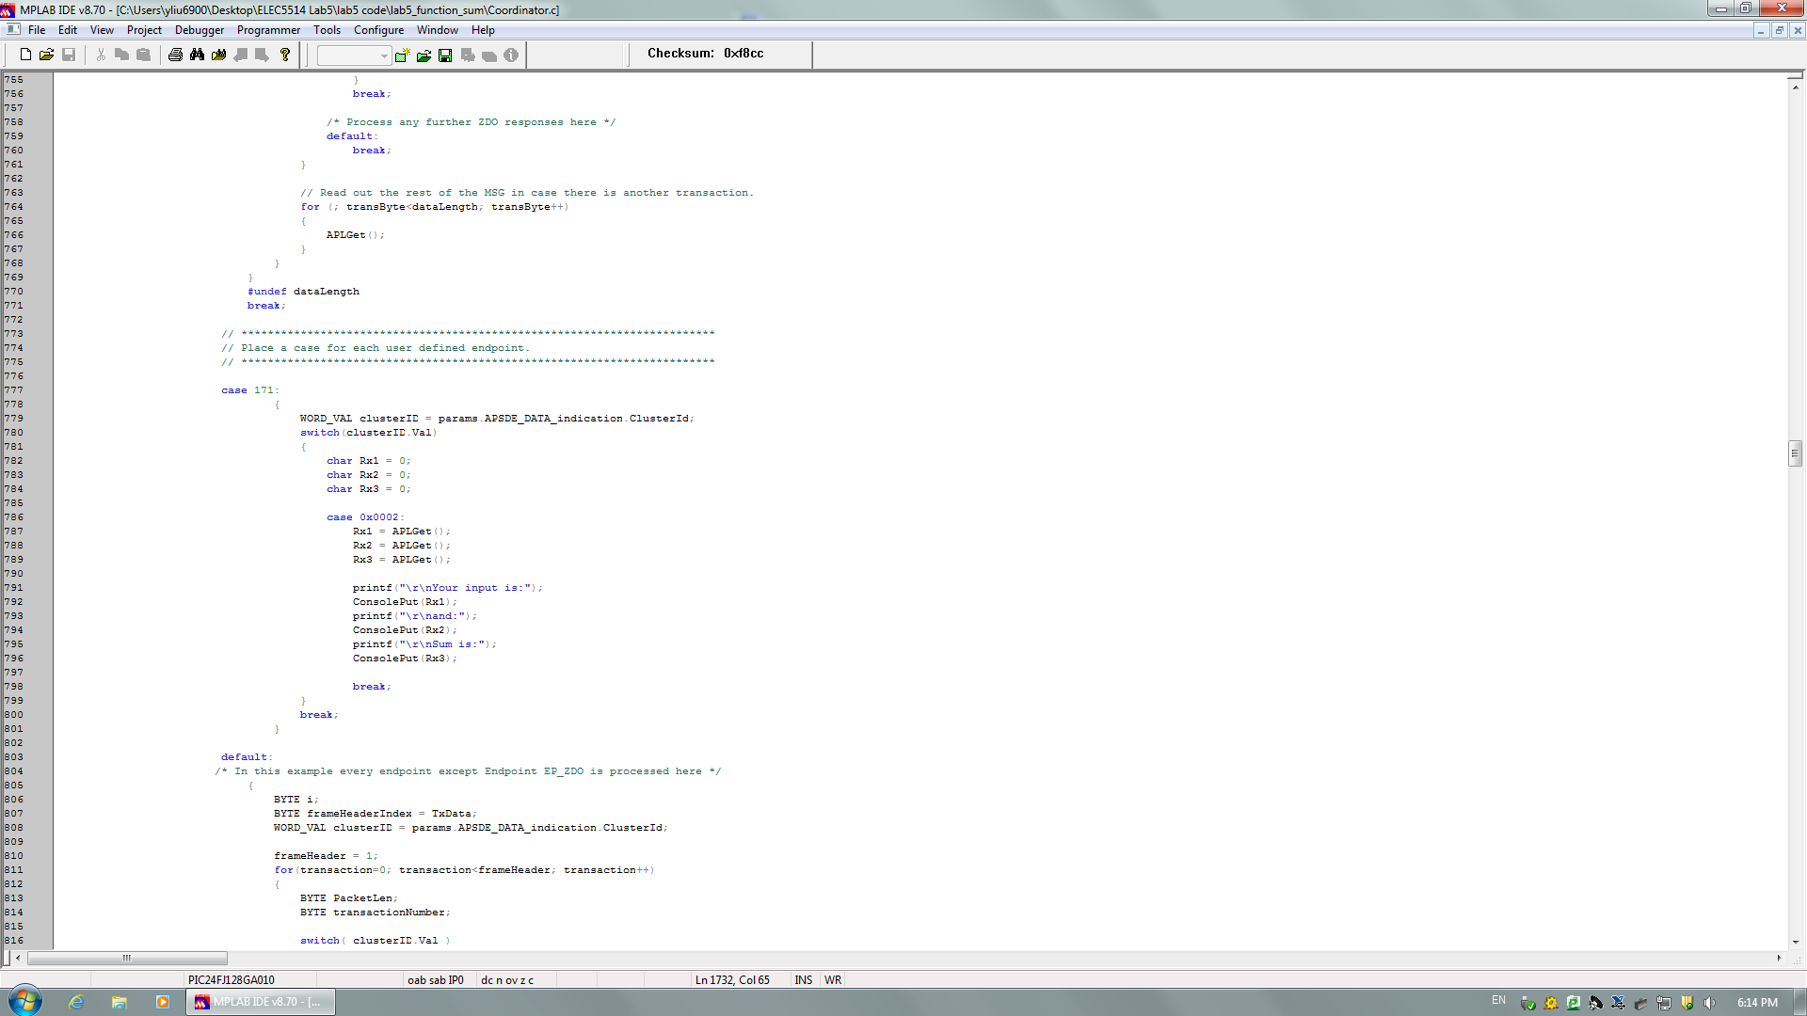

Figure 5.3

Here are the transmission details displayed on ZENA:

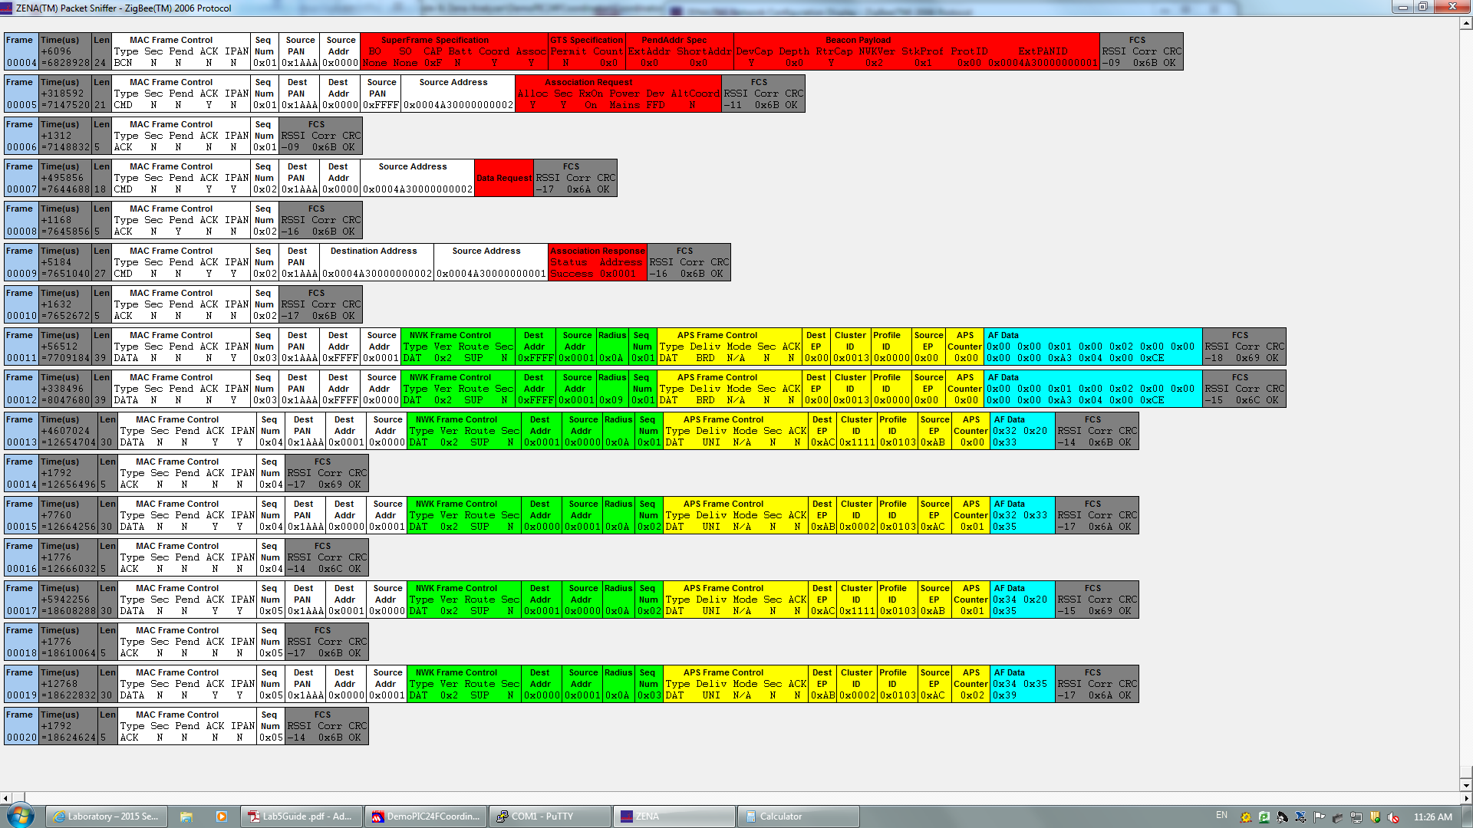

Figure 5.4

The Console output is:

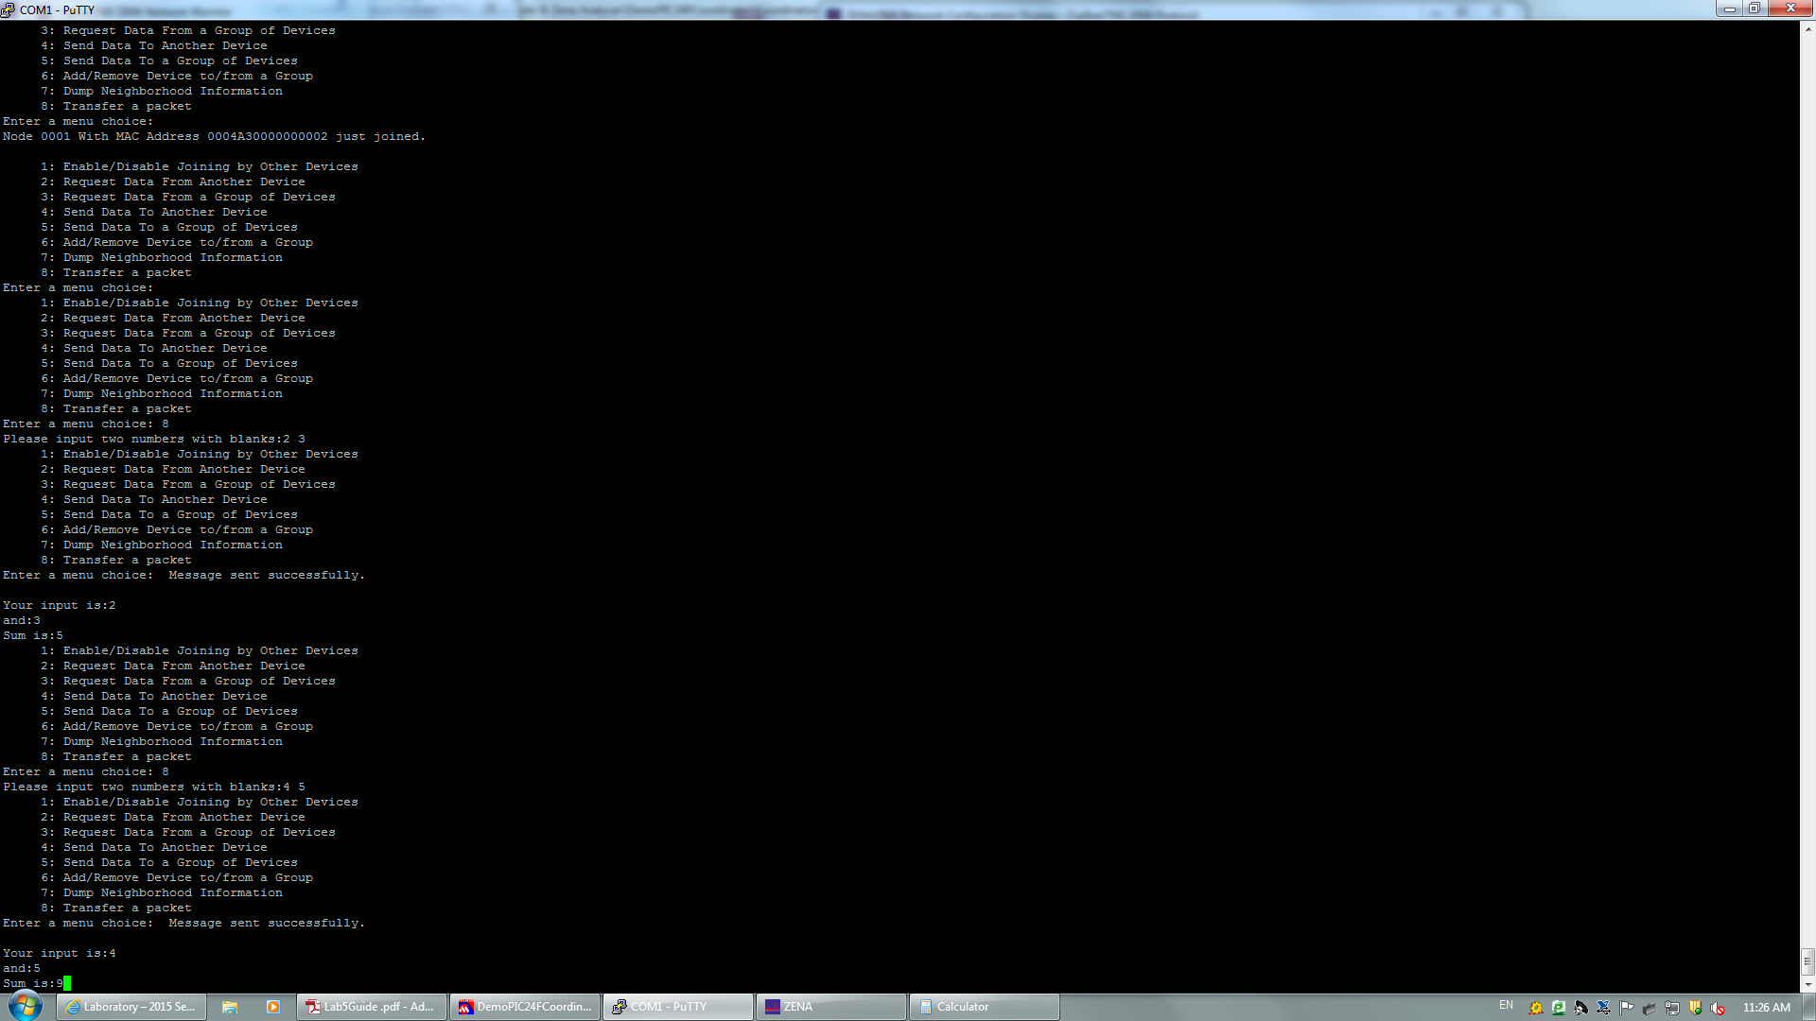

Figure 5.5

**2.2 Task 2:**

The program is as below:

Coordinator transmits the number from 256-999 to router:

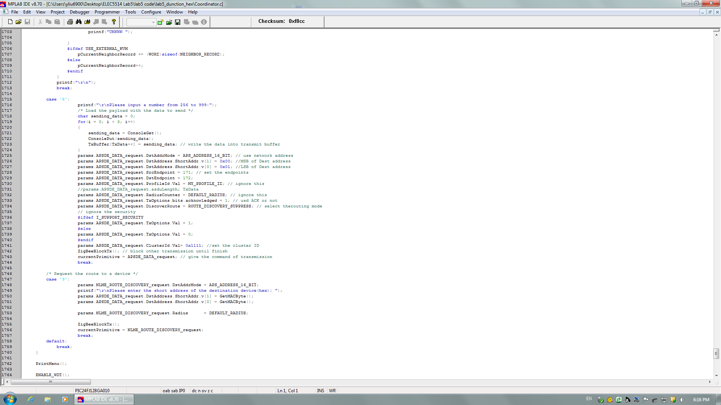

Figure 5.6

Router receives the packet and calculate the hex value of the number, then transmit it back to coordinator:

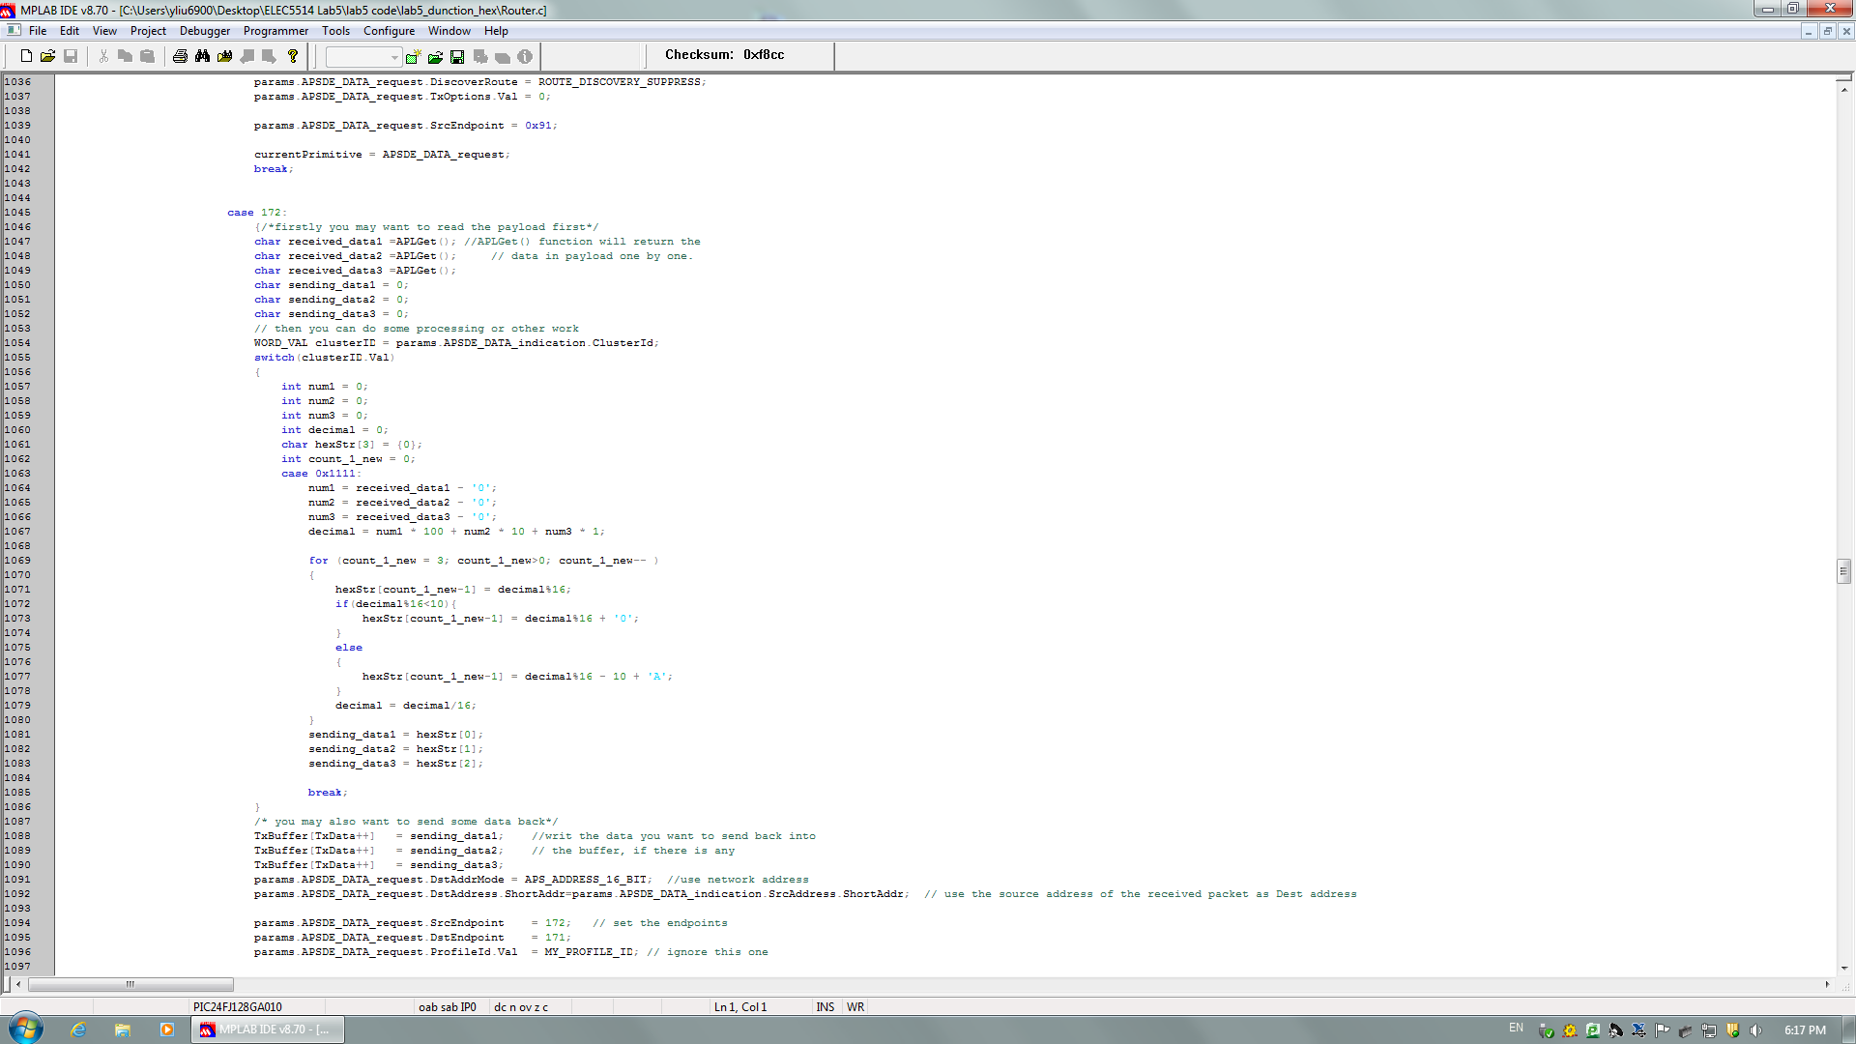

Figure 5.7

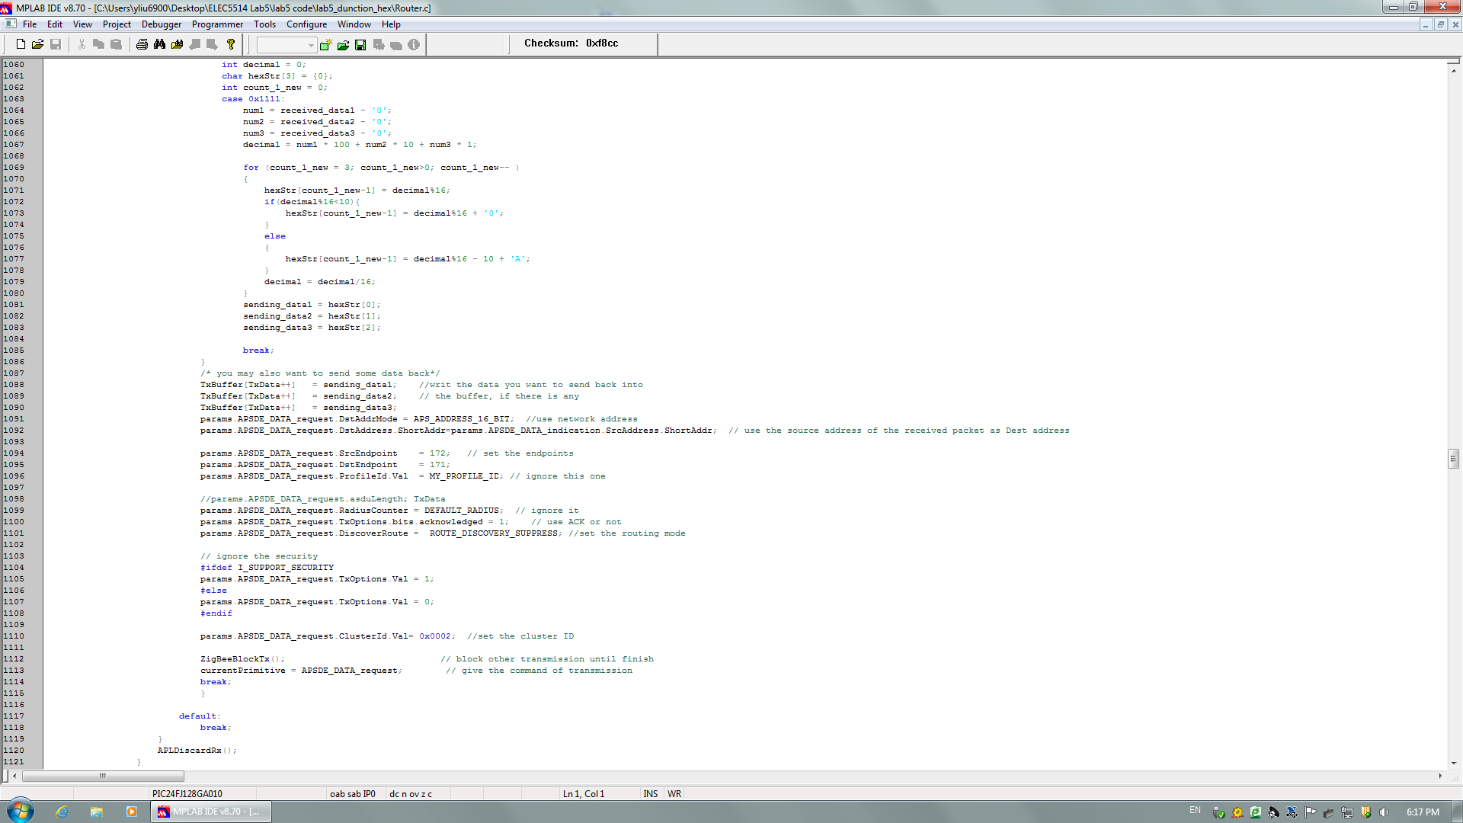

Figure 5.8

Coordinate receives the hex value and display it on the console:

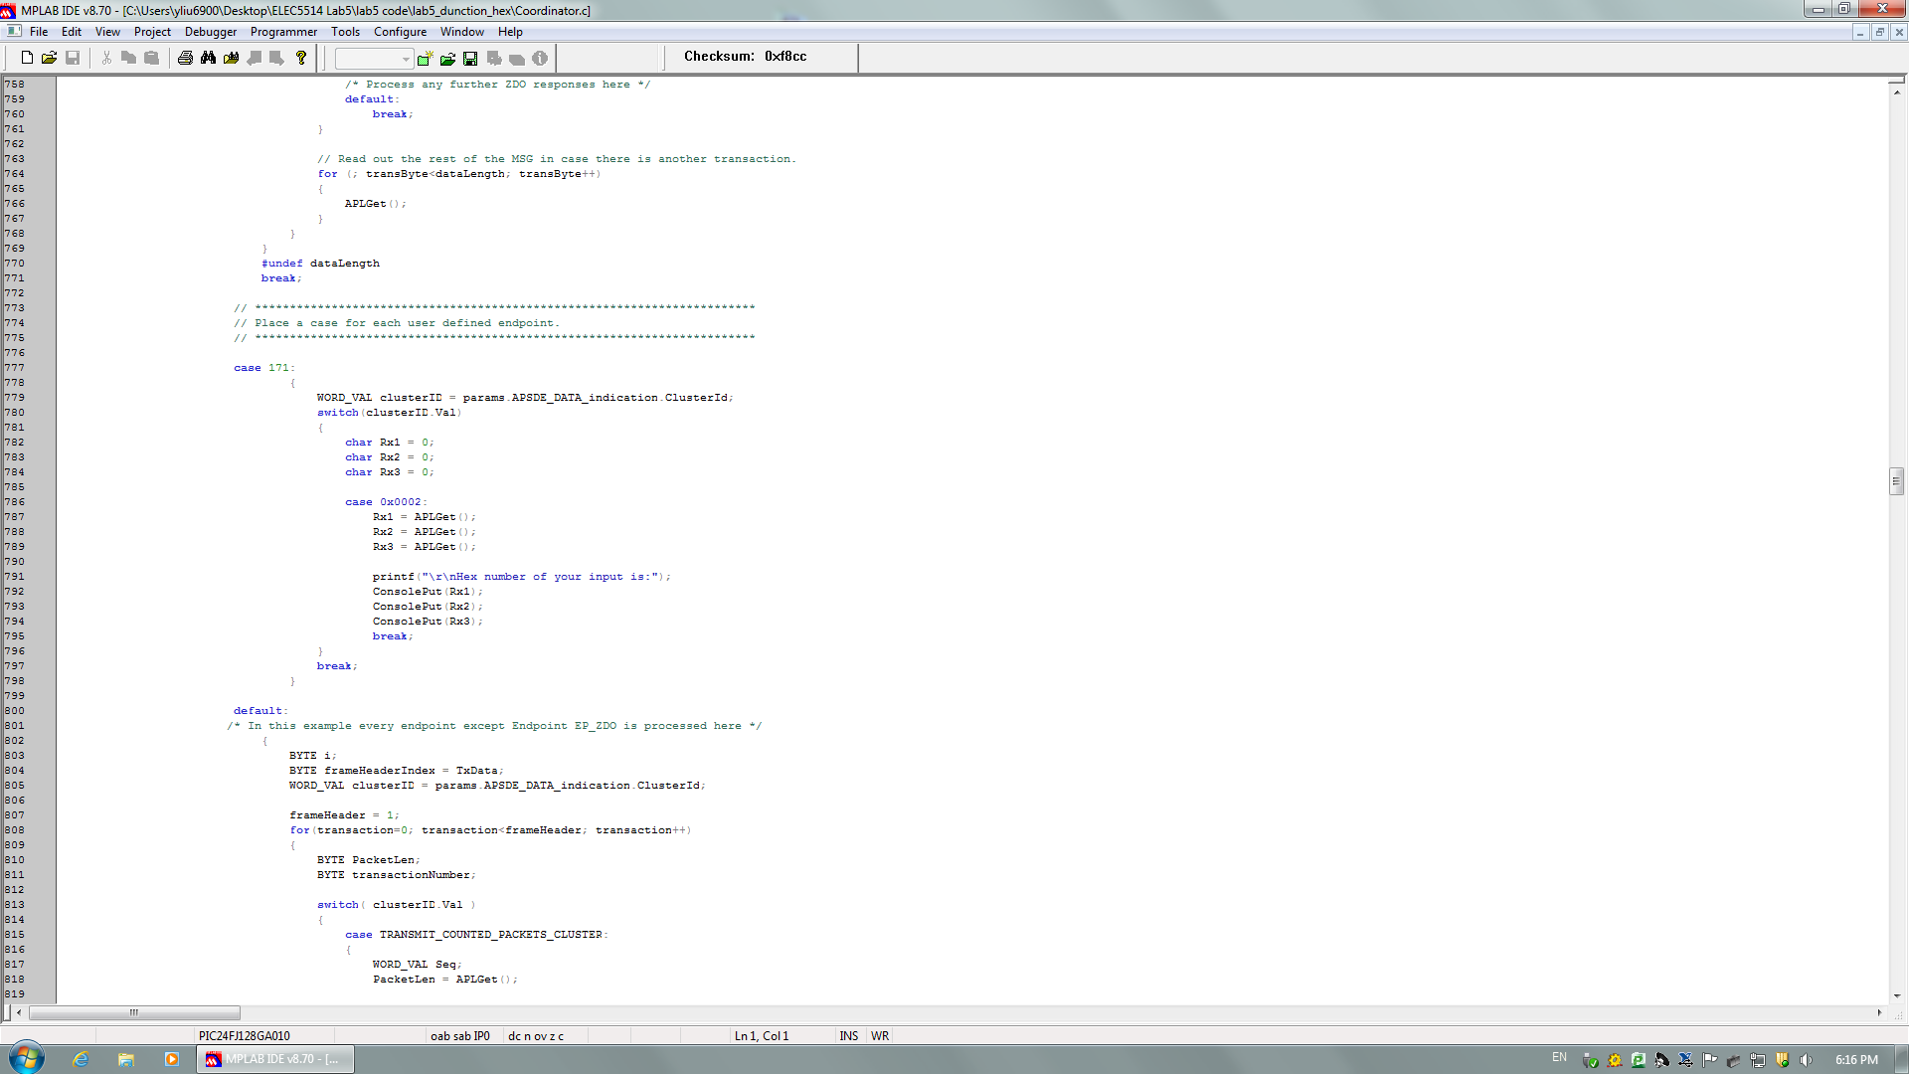

Figure 5.9

Here ares the transmission details displayed on ZENA:

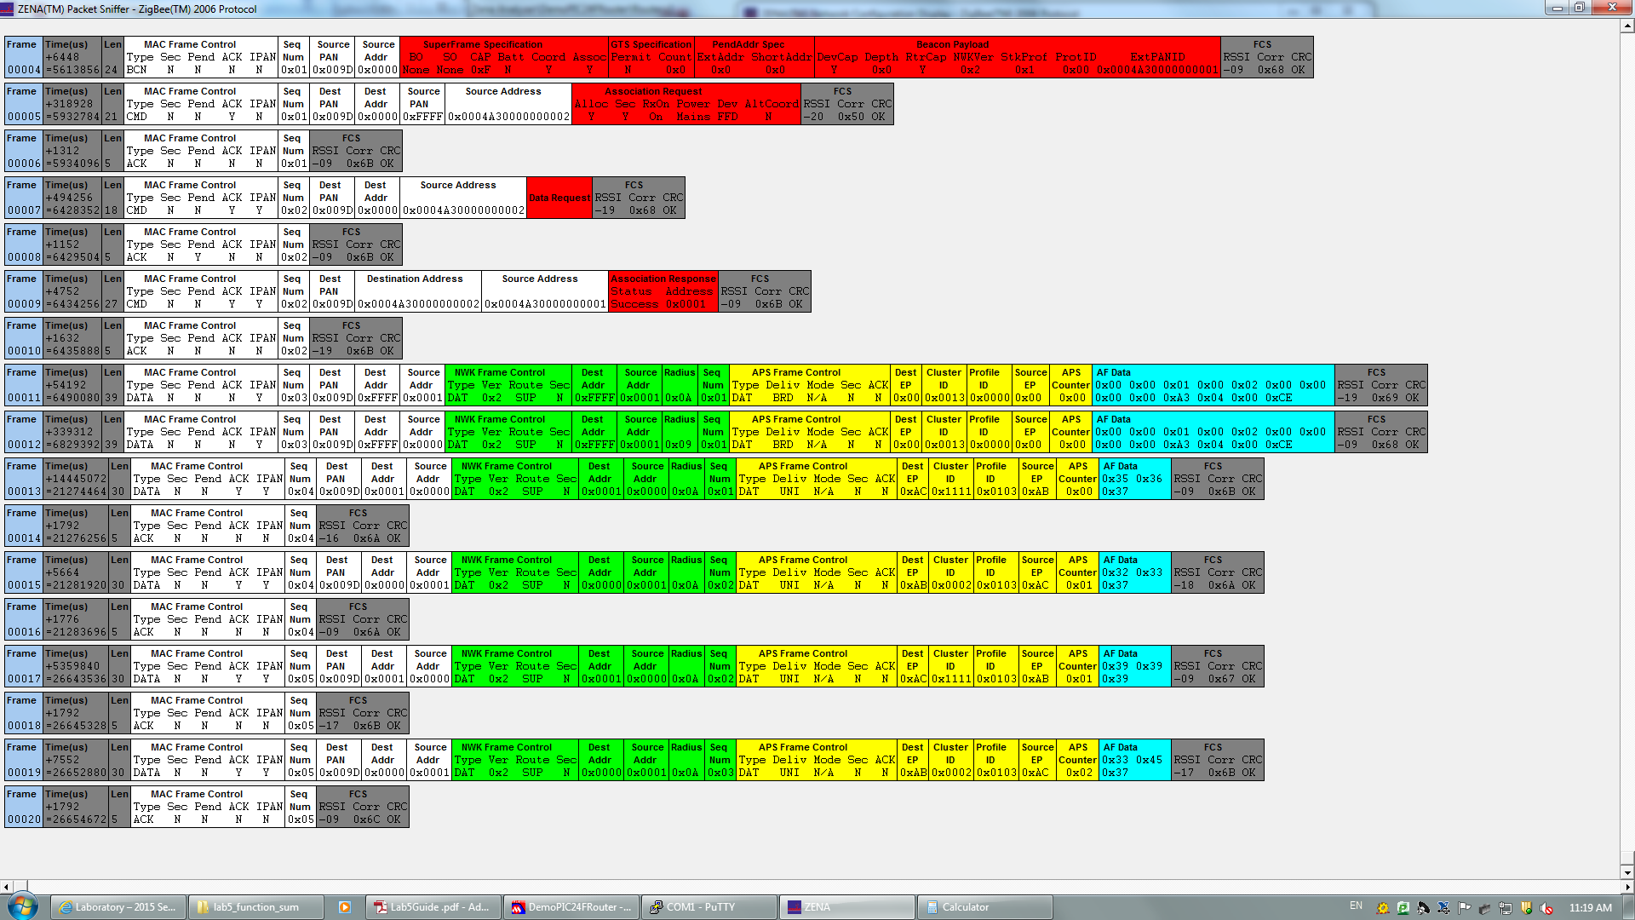

Figure 5.10

The Console output is:

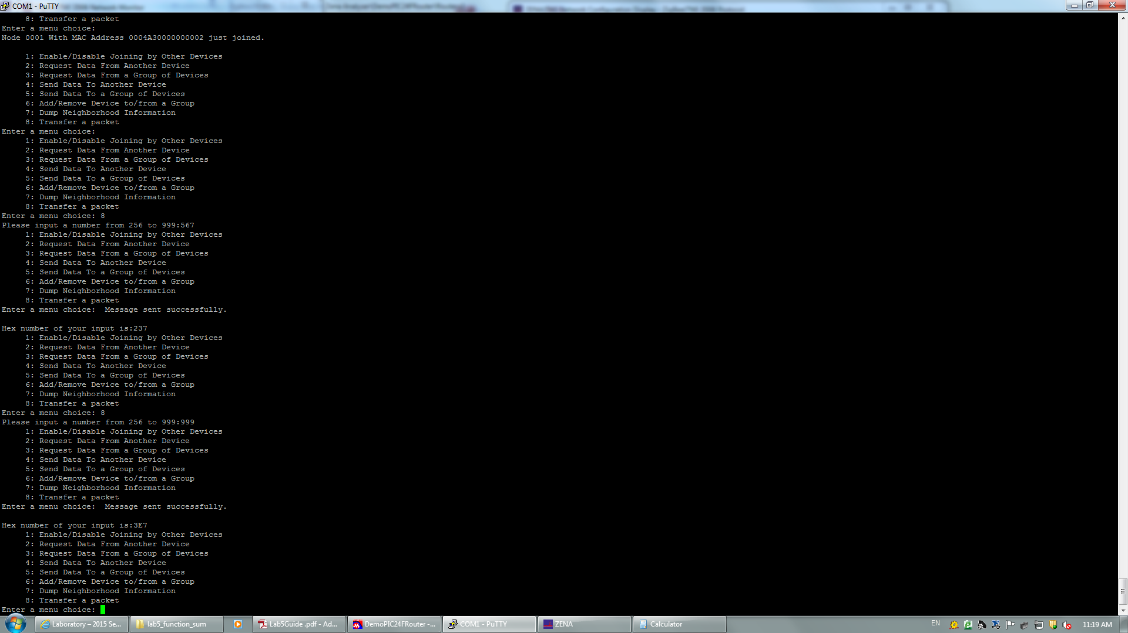

Figure 5.11

### III. Conclusion

We combined the knowledge we learned in the previous labs. We got deep understand of the wireless sensor network and knew the basic working modes of the ZigBee networks.